**Коллажи из пуговиц**

[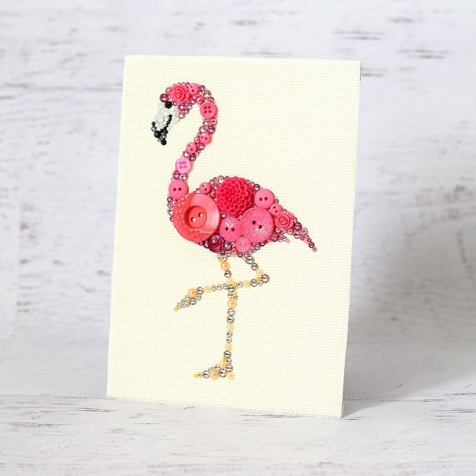](https://ok.ru/dk?cmd=PopLayerPhoto&st.layer.cmd=PopLayerPhotoOuter&st.layer.type=GROUP&st.layer.revNav=off&st.layer.limitedUi=false&st.layer.sphotoIds=851029443658;851029443402;851029443146;851029442890;851029442634;851029442378;851029442122;851029441866;851029441610&st.layer.showNav=on&st.layer.photoAlbumId=52556583141450&st.layer.epm=off&st.layer.photoId=851029443658&st.layer.opl=off&st.layer.navStartPhotoId=851029443658&st.layer.sbd=off&st.cmd=altGroupMain&st.groupId=52556583010378&st.referenceName=kopilkadl&st._aid=GroupTopicLayer_openPhotoLayer)

[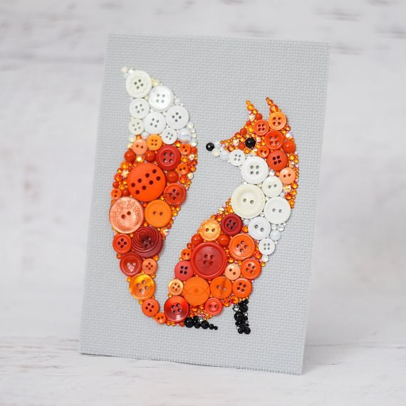](https://ok.ru/dk?cmd=PopLayerPhoto&st.layer.cmd=PopLayerPhotoOuter&st.layer.type=GROUP&st.layer.revNav=off&st.layer.limitedUi=false&st.layer.sphotoIds=851029443658;851029443402;851029443146;851029442890;851029442634;851029442378;851029442122;851029441866;851029441610&st.layer.showNav=on&st.layer.photoAlbumId=52556583141450&st.layer.epm=off&st.layer.photoId=851029443402&st.layer.opl=off&st.layer.navStartPhotoId=851029443402&st.layer.sbd=off&st.cmd=altGroupMain&st.groupId=52556583010378&st.referenceName=kopilkadl&st._aid=GroupTopicLayer_openPhotoLayer)

[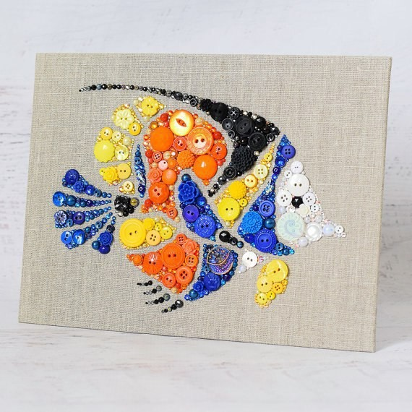](https://ok.ru/dk?cmd=PopLayerPhoto&st.layer.cmd=PopLayerPhotoOuter&st.layer.type=GROUP&st.layer.revNav=off&st.layer.limitedUi=false&st.layer.sphotoIds=851029443658;851029443402;851029443146;851029442890;851029442634;851029442378;851029442122;851029441866;851029441610&st.layer.showNav=on&st.layer.photoAlbumId=52556583141450&st.layer.epm=off&st.layer.photoId=851029443146&st.layer.opl=off&st.layer.navStartPhotoId=851029443146&st.layer.sbd=off&st.cmd=altGroupMain&st.groupId=52556583010378&st.referenceName=kopilkadl&st._aid=GroupTopicLayer_openPhotoLayer)

[](https://ok.ru/dk?cmd=PopLayerPhoto&st.layer.cmd=PopLayerPhotoOuter&st.layer.type=GROUP&st.layer.revNav=off&st.layer.limitedUi=false&st.layer.sphotoIds=851029443658;851029443402;851029443146;851029442890;851029442634;851029442378;851029442122;851029441866;851029441610&st.layer.showNav=on&st.layer.photoAlbumId=52556583141450&st.layer.epm=off&st.layer.photoId=851029442890&st.layer.opl=off&st.layer.navStartPhotoId=851029442890&st.layer.sbd=off&st.cmd=altGroupMain&st.groupId=52556583010378&st.referenceName=kopilkadl&st._aid=GroupTopicLayer_openPhotoLayer)

[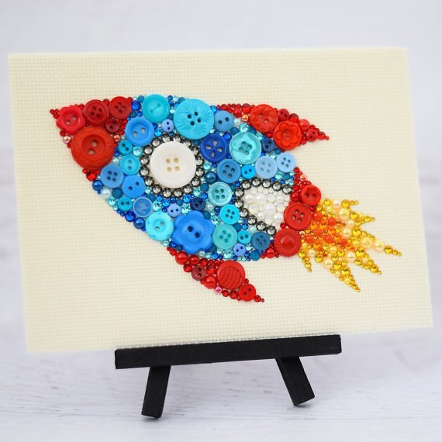](https://ok.ru/dk?cmd=PopLayerPhoto&st.layer.cmd=PopLayerPhotoOuter&st.layer.type=GROUP&st.layer.revNav=off&st.layer.limitedUi=false&st.layer.sphotoIds=851029443658;851029443402;851029443146;851029442890;851029442634;851029442378;851029442122;851029441866;851029441610&st.layer.showNav=on&st.layer.photoAlbumId=52556583141450&st.layer.epm=off&st.layer.photoId=851029442634&st.layer.opl=off&st.layer.navStartPhotoId=851029442634&st.layer.sbd=off&st.cmd=altGroupMain&st.groupId=52556583010378&st.referenceName=kopilkadl&st._aid=GroupTopicLayer_openPhotoLayer)

[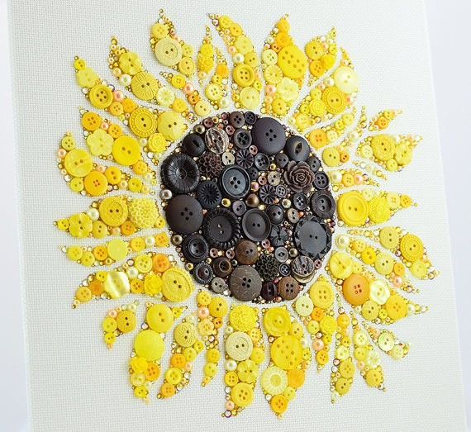](https://ok.ru/dk?cmd=PopLayerPhoto&st.layer.cmd=PopLayerPhotoOuter&st.layer.type=GROUP&st.layer.revNav=off&st.layer.limitedUi=false&st.layer.sphotoIds=851029443658;851029443402;851029443146;851029442890;851029442634;851029442378;851029442122;851029441866;851029441610&st.layer.showNav=on&st.layer.photoAlbumId=52556583141450&st.layer.epm=off&st.layer.photoId=851029442378&st.layer.opl=off&st.layer.navStartPhotoId=851029442378&st.layer.sbd=off&st.cmd=altGroupMain&st.groupId=52556583010378&st.referenceName=kopilkadl&st._aid=GroupTopicLayer_openPhotoLayer)

[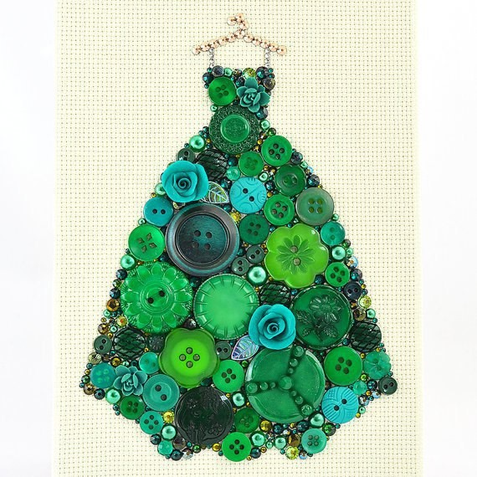](https://ok.ru/dk?cmd=PopLayerPhoto&st.layer.cmd=PopLayerPhotoOuter&st.layer.type=GROUP&st.layer.revNav=off&st.layer.limitedUi=false&st.layer.sphotoIds=851029443658;851029443402;851029443146;851029442890;851029442634;851029442378;851029442122;851029441866;851029441610&st.layer.showNav=on&st.layer.photoAlbumId=52556583141450&st.layer.epm=off&st.layer.photoId=851029442122&st.layer.opl=off&st.layer.navStartPhotoId=851029442122&st.layer.sbd=off&st.cmd=altGroupMain&st.groupId=52556583010378&st.referenceName=kopilkadl&st._aid=GroupTopicLayer_openPhotoLayer)

[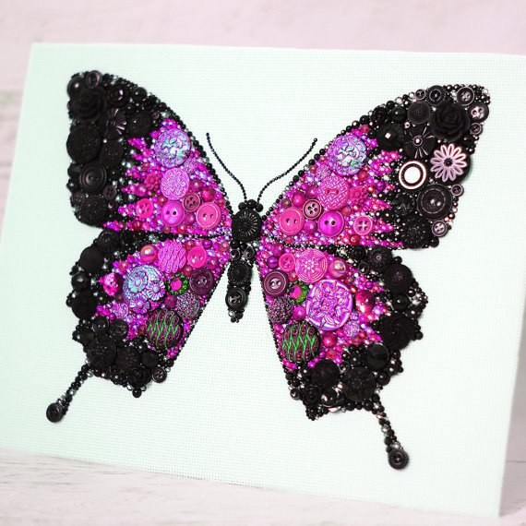](https://ok.ru/dk?cmd=PopLayerPhoto&st.layer.cmd=PopLayerPhotoOuter&st.layer.type=GROUP&st.layer.revNav=off&st.layer.limitedUi=false&st.layer.sphotoIds=851029443658;851029443402;851029443146;851029442890;851029442634;851029442378;851029442122;851029441866;851029441610&st.layer.showNav=on&st.layer.photoAlbumId=52556583141450&st.layer.epm=off&st.layer.photoId=851029441866&st.layer.opl=off&st.layer.navStartPhotoId=851029441866&st.layer.sbd=off&st.cmd=altGroupMain&st.groupId=52556583010378&st.referenceName=kopilkadl&st._aid=GroupTopicLayer_openPhotoLayer)

[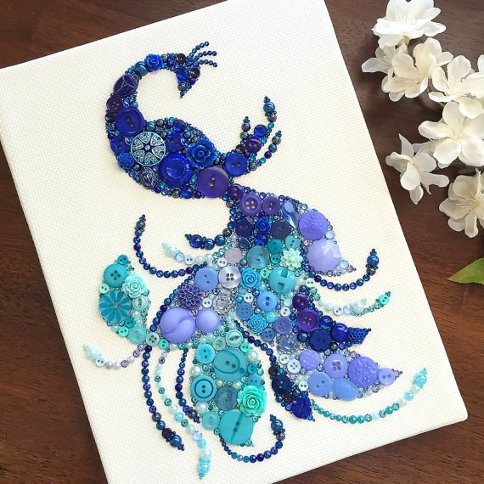](https://ok.ru/dk?cmd=PopLayerPhoto&st.layer.cmd=PopLayerPhotoOuter&st.layer.type=GROUP&st.layer.revNav=off&st.layer.limitedUi=false&st.layer.sphotoIds=851029443658;851029443402;851029443146;851029442890;851029442634;851029442378;851029442122;851029441866;851029441610&st.layer.showNav=on&st.layer.photoAlbumId=52556583141450&st.layer.epm=off&st.layer.photoId=851029441610&st.layer.opl=off&st.layer.navStartPhotoId=851029441610&st.layer.sbd=off&st.cmd=altGroupMain&st.groupId=52556583010378&st.referenceName=kopilkadl&st._aid=GroupTopicLayer_openPhotoLayer)

• •