[](https://ok.ru/dk?cmd=PopLayerPhoto&st.layer.cmd=PopLayerPhotoOuter&st.layer.type=GROUP&st.layer.revNav=off&st.layer.limitedUi=false&st.layer.closeLayers=off&st.layer.sphotoIds=879705524707;879705524963;879705525219;879705525475;879705525731;879705525987;879705526243;879705526499;879705526755;879705527011&st.layer.showNav=on&st.layer.photoAlbumId=54335204229347&st.layer.epm=off&st.layer.photoId=879705524707&st.layer.opl=off&st.layer.navStartPhotoId=879705524707&st.layer.sbd=off&st.cmd=altGroupMain&st.groupId=54335192826083&st.referenceName=podelkabelka&st._aid=GroupTopicLayer_openPhotoLayer)

[](https://ok.ru/dk?cmd=PopLayerPhoto&st.layer.cmd=PopLayerPhotoOuter&st.layer.type=GROUP&st.layer.revNav=off&st.layer.limitedUi=false&st.layer.closeLayers=off&st.layer.sphotoIds=879705524707;879705524963;879705525219;879705525475;879705525731;879705525987;879705526243;879705526499;879705526755;879705527011&st.layer.showNav=on&st.layer.photoAlbumId=54335204229347&st.layer.epm=off&st.layer.photoId=879705524963&st.layer.opl=off&st.layer.navStartPhotoId=879705524963&st.layer.sbd=off&st.cmd=altGroupMain&st.groupId=54335192826083&st.referenceName=podelkabelka&st._aid=GroupTopicLayer_openPhotoLayer)

[](https://ok.ru/dk?cmd=PopLayerPhoto&st.layer.cmd=PopLayerPhotoOuter&st.layer.type=GROUP&st.layer.revNav=off&st.layer.limitedUi=false&st.layer.closeLayers=off&st.layer.sphotoIds=879705524707;879705524963;879705525219;879705525475;879705525731;879705525987;879705526243;879705526499;879705526755;879705527011&st.layer.showNav=on&st.layer.photoAlbumId=54335204229347&st.layer.epm=off&st.layer.photoId=879705525219&st.layer.opl=off&st.layer.navStartPhotoId=879705525219&st.layer.sbd=off&st.cmd=altGroupMain&st.groupId=54335192826083&st.referenceName=podelkabelka&st._aid=GroupTopicLayer_openPhotoLayer)

[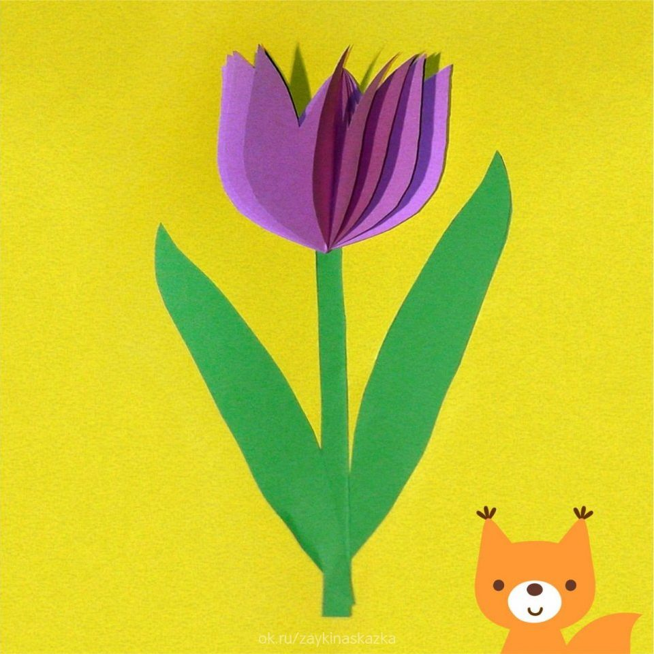](https://ok.ru/dk?cmd=PopLayerPhoto&st.layer.cmd=PopLayerPhotoOuter&st.layer.type=GROUP&st.layer.revNav=off&st.layer.limitedUi=false&st.layer.closeLayers=off&st.layer.sphotoIds=879705524707;879705524963;879705525219;879705525475;879705525731;879705525987;879705526243;879705526499;879705526755;879705527011&st.layer.showNav=on&st.layer.photoAlbumId=54335204229347&st.layer.epm=off&st.layer.photoId=879705525475&st.layer.opl=off&st.layer.navStartPhotoId=879705525475&st.layer.sbd=off&st.cmd=altGroupMain&st.groupId=54335192826083&st.referenceName=podelkabelka&st._aid=GroupTopicLayer_openPhotoLayer)

[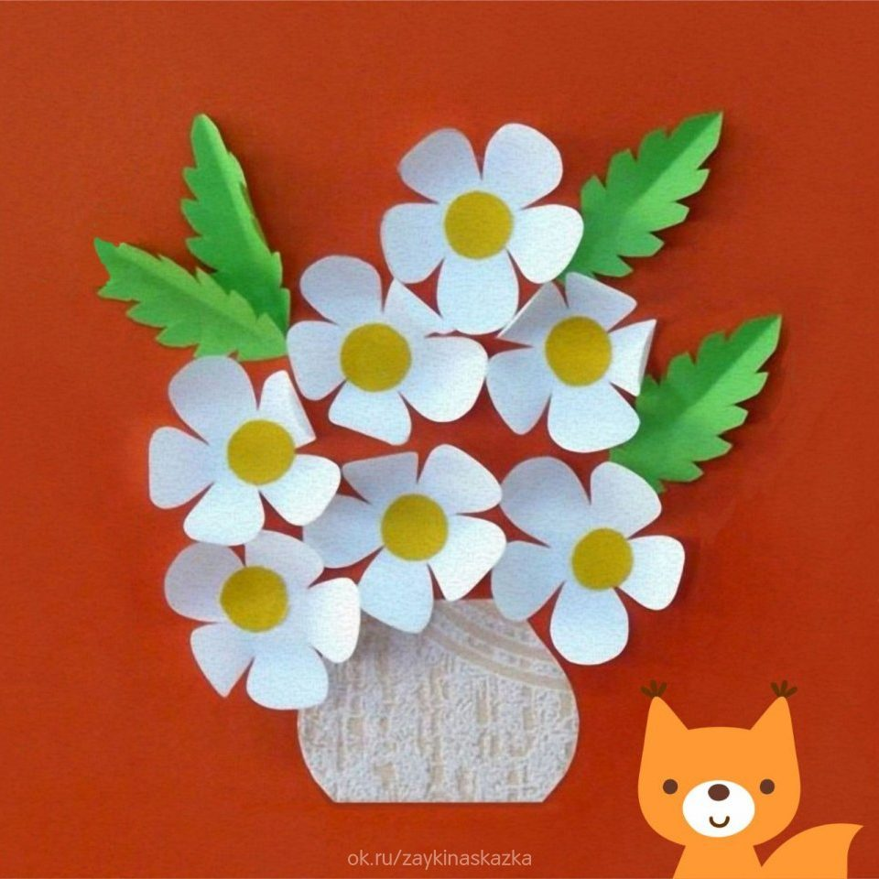](https://ok.ru/dk?cmd=PopLayerPhoto&st.layer.cmd=PopLayerPhotoOuter&st.layer.type=GROUP&st.layer.revNav=off&st.layer.limitedUi=false&st.layer.closeLayers=off&st.layer.sphotoIds=879705524707;879705524963;879705525219;879705525475;879705525731;879705525987;879705526243;879705526499;879705526755;879705527011&st.layer.showNav=on&st.layer.photoAlbumId=54335204229347&st.layer.epm=off&st.layer.photoId=879705525731&st.layer.opl=off&st.layer.navStartPhotoId=879705525731&st.layer.sbd=off&st.cmd=altGroupMain&st.groupId=54335192826083&st.referenceName=podelkabelka&st._aid=GroupTopicLayer_openPhotoLayer)

[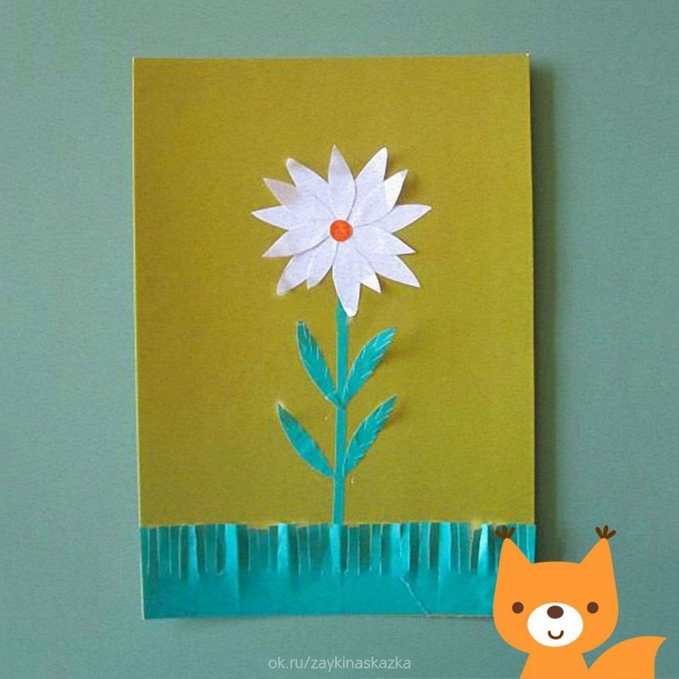](https://ok.ru/dk?cmd=PopLayerPhoto&st.layer.cmd=PopLayerPhotoOuter&st.layer.type=GROUP&st.layer.revNav=off&st.layer.limitedUi=false&st.layer.closeLayers=off&st.layer.sphotoIds=879705524707;879705524963;879705525219;879705525475;879705525731;879705525987;879705526243;879705526499;879705526755;879705527011&st.layer.showNav=on&st.layer.photoAlbumId=54335204229347&st.layer.epm=off&st.layer.photoId=879705525987&st.layer.opl=off&st.layer.navStartPhotoId=879705525987&st.layer.sbd=off&st.cmd=altGroupMain&st.groupId=54335192826083&st.referenceName=podelkabelka&st._aid=GroupTopicLayer_openPhotoLayer)

[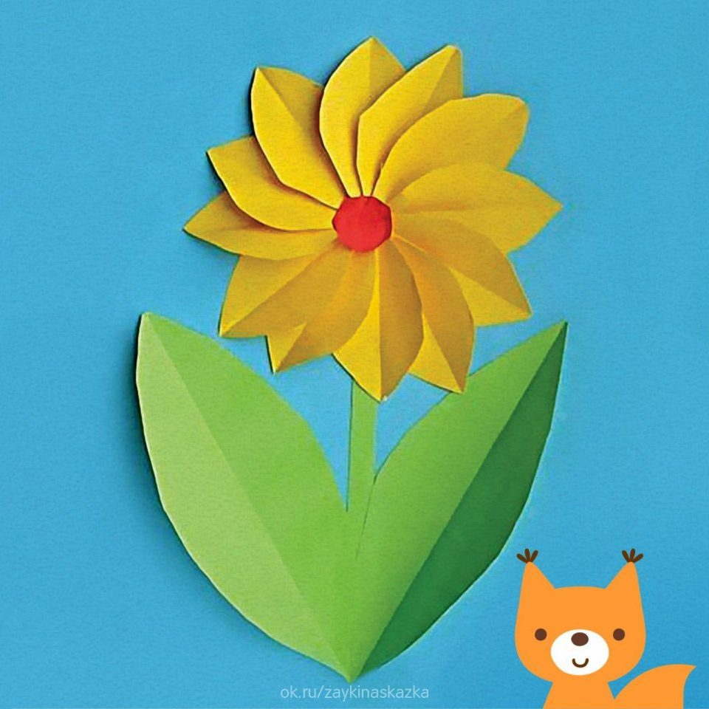](https://ok.ru/dk?cmd=PopLayerPhoto&st.layer.cmd=PopLayerPhotoOuter&st.layer.type=GROUP&st.layer.revNav=off&st.layer.limitedUi=false&st.layer.closeLayers=off&st.layer.sphotoIds=879705524707;879705524963;879705525219;879705525475;879705525731;879705525987;879705526243;879705526499;879705526755;879705527011&st.layer.showNav=on&st.layer.photoAlbumId=54335204229347&st.layer.epm=off&st.layer.photoId=879705526243&st.layer.opl=off&st.layer.navStartPhotoId=879705526243&st.layer.sbd=off&st.cmd=altGroupMain&st.groupId=54335192826083&st.referenceName=podelkabelka&st._aid=GroupTopicLayer_openPhotoLayer)

[](https://ok.ru/dk?cmd=PopLayerPhoto&st.layer.cmd=PopLayerPhotoOuter&st.layer.type=GROUP&st.layer.revNav=off&st.layer.limitedUi=false&st.layer.closeLayers=off&st.layer.sphotoIds=879705524707;879705524963;879705525219;879705525475;879705525731;879705525987;879705526243;879705526499;879705526755;879705527011&st.layer.showNav=on&st.layer.photoAlbumId=54335204229347&st.layer.epm=off&st.layer.photoId=879705526499&st.layer.opl=off&st.layer.navStartPhotoId=879705526499&st.layer.sbd=off&st.cmd=altGroupMain&st.groupId=54335192826083&st.referenceName=podelkabelka&st._aid=GroupTopicLayer_openPhotoLayer)

[](https://ok.ru/dk?cmd=PopLayerPhoto&st.layer.cmd=PopLayerPhotoOuter&st.layer.type=GROUP&st.layer.revNav=off&st.layer.limitedUi=false&st.layer.closeLayers=off&st.layer.sphotoIds=879705524707;879705524963;879705525219;879705525475;879705525731;879705525987;879705526243;879705526499;879705526755;879705527011&st.layer.showNav=on&st.layer.photoAlbumId=54335204229347&st.layer.epm=off&st.layer.photoId=879705526755&st.layer.opl=off&st.layer.navStartPhotoId=879705526755&st.layer.sbd=off&st.cmd=altGroupMain&st.groupId=54335192826083&st.referenceName=podelkabelka&st._aid=GroupTopicLayer_openPhotoLayer)

[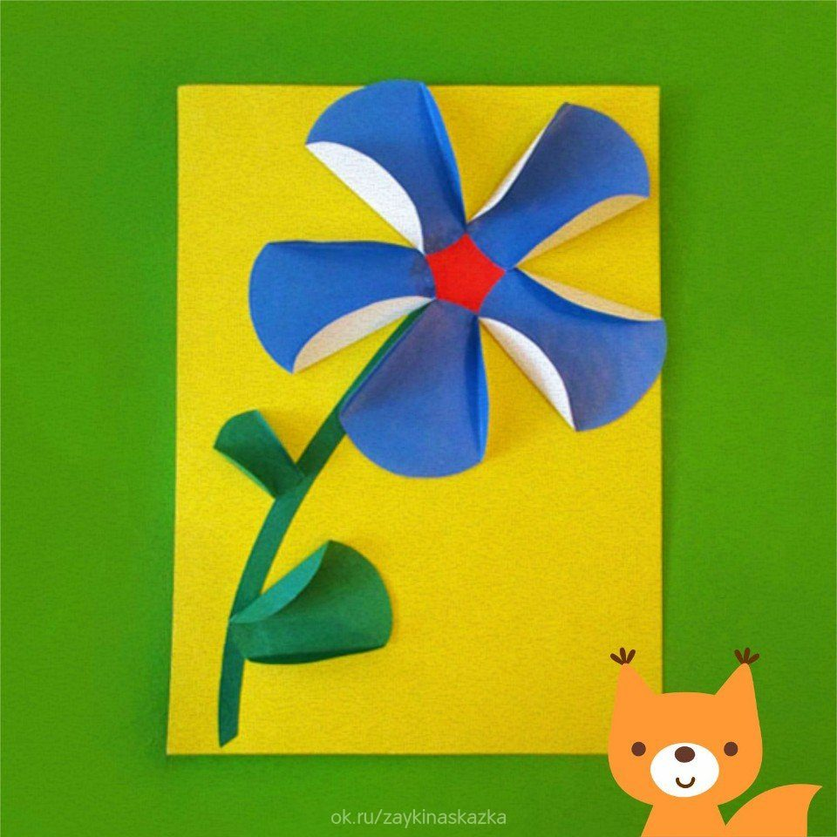](https://ok.ru/dk?cmd=PopLayerPhoto&st.layer.cmd=PopLayerPhotoOuter&st.layer.type=GROUP&st.layer.revNav=off&st.layer.limitedUi=false&st.layer.closeLayers=off&st.layer.sphotoIds=879705524707;879705524963;879705525219;879705525475;879705525731;879705525987;879705526243;879705526499;879705526755;879705527011&st.layer.showNav=on&st.layer.photoAlbumId=54335204229347&st.layer.epm=off&st.layer.photoId=879705527011&st.layer.opl=off&st.layer.navStartPhotoId=879705527011&st.layer.sbd=off&st.cmd=altGroupMain&st.groupId=54335192826083&st.referenceName=podelkabelka&st._aid=GroupTopicLayer_openPhotoLayer)