**Поздравление с 8 Марта.**

**Открытка "Корзина с цветами"**

[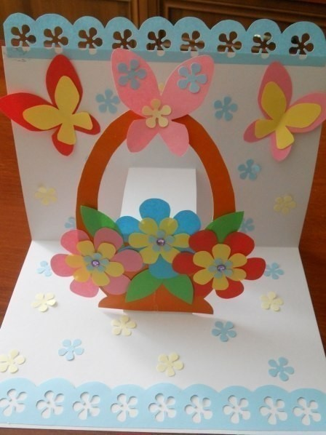](https://ok.ru/dk?cmd=PopLayerPhoto&st.layer.cmd=PopLayerPhotoOuter&st.layer.type=GROUP&st.layer.revNav=off&st.layer.limitedUi=false&st.layer.sphotoIds=852245390388;852245390644;852245390900;852245391156;852245391412;852245391668;852245391924;852245392180;852245392436&st.layer.showNav=on&st.layer.photoAlbumId=57249062780980&st.layer.epm=off&st.layer.photoId=852245390388&st.layer.opl=off&st.layer.navStartPhotoId=852245390388&st.layer.sbd=off&st.cmd=altGroupMain&st.groupId=57249006420020&st.referenceName=chudovospi&st._aid=GroupTopicLayer_openPhotoLayer)

[](https://ok.ru/dk?cmd=PopLayerPhoto&st.layer.cmd=PopLayerPhotoOuter&st.layer.type=GROUP&st.layer.revNav=off&st.layer.limitedUi=false&st.layer.sphotoIds=852245390388;852245390644;852245390900;852245391156;852245391412;852245391668;852245391924;852245392180;852245392436&st.layer.showNav=on&st.layer.photoAlbumId=57249062780980&st.layer.epm=off&st.layer.photoId=852245390644&st.layer.opl=off&st.layer.navStartPhotoId=852245390644&st.layer.sbd=off&st.cmd=altGroupMain&st.groupId=57249006420020&st.referenceName=chudovospi&st._aid=GroupTopicLayer_openPhotoLayer)

[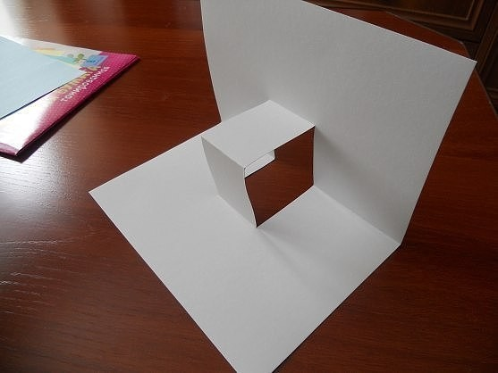](https://ok.ru/dk?cmd=PopLayerPhoto&st.layer.cmd=PopLayerPhotoOuter&st.layer.type=GROUP&st.layer.revNav=off&st.layer.limitedUi=false&st.layer.sphotoIds=852245390388;852245390644;852245390900;852245391156;852245391412;852245391668;852245391924;852245392180;852245392436&st.layer.showNav=on&st.layer.photoAlbumId=57249062780980&st.layer.epm=off&st.layer.photoId=852245390900&st.layer.opl=off&st.layer.navStartPhotoId=852245390900&st.layer.sbd=off&st.cmd=altGroupMain&st.groupId=57249006420020&st.referenceName=chudovospi&st._aid=GroupTopicLayer_openPhotoLayer)

[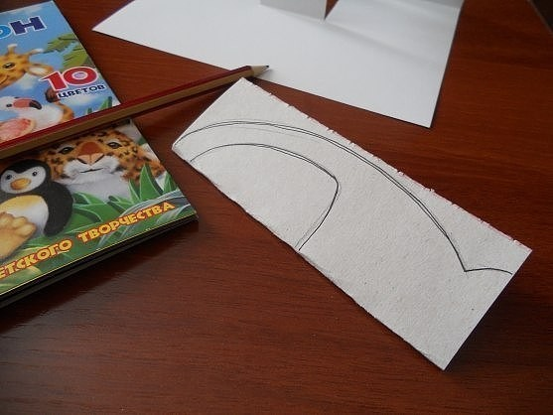](https://ok.ru/dk?cmd=PopLayerPhoto&st.layer.cmd=PopLayerPhotoOuter&st.layer.type=GROUP&st.layer.revNav=off&st.layer.limitedUi=false&st.layer.sphotoIds=852245390388;852245390644;852245390900;852245391156;852245391412;852245391668;852245391924;852245392180;852245392436&st.layer.showNav=on&st.layer.photoAlbumId=57249062780980&st.layer.epm=off&st.layer.photoId=852245391156&st.layer.opl=off&st.layer.navStartPhotoId=852245391156&st.layer.sbd=off&st.cmd=altGroupMain&st.groupId=57249006420020&st.referenceName=chudovospi&st._aid=GroupTopicLayer_openPhotoLayer)

[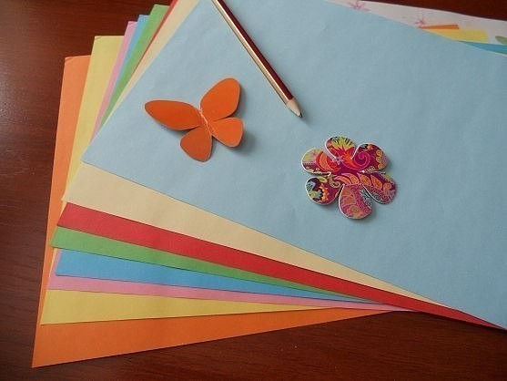](https://ok.ru/dk?cmd=PopLayerPhoto&st.layer.cmd=PopLayerPhotoOuter&st.layer.type=GROUP&st.layer.revNav=off&st.layer.limitedUi=false&st.layer.sphotoIds=852245390388;852245390644;852245390900;852245391156;852245391412;852245391668;852245391924;852245392180;852245392436&st.layer.showNav=on&st.layer.photoAlbumId=57249062780980&st.layer.epm=off&st.layer.photoId=852245391412&st.layer.opl=off&st.layer.navStartPhotoId=852245391412&st.layer.sbd=off&st.cmd=altGroupMain&st.groupId=57249006420020&st.referenceName=chudovospi&st._aid=GroupTopicLayer_openPhotoLayer)

[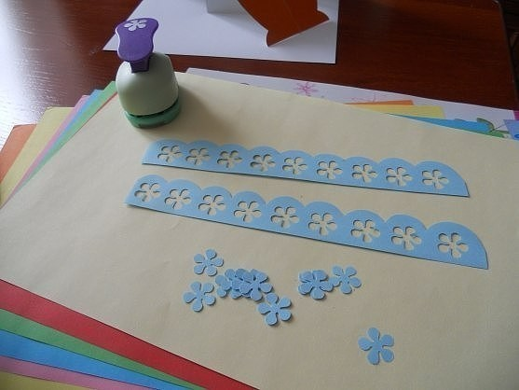](https://ok.ru/dk?cmd=PopLayerPhoto&st.layer.cmd=PopLayerPhotoOuter&st.layer.type=GROUP&st.layer.revNav=off&st.layer.limitedUi=false&st.layer.sphotoIds=852245390388;852245390644;852245390900;852245391156;852245391412;852245391668;852245391924;852245392180;852245392436&st.layer.showNav=on&st.layer.photoAlbumId=57249062780980&st.layer.epm=off&st.layer.photoId=852245391668&st.layer.opl=off&st.layer.navStartPhotoId=852245391668&st.layer.sbd=off&st.cmd=altGroupMain&st.groupId=57249006420020&st.referenceName=chudovospi&st._aid=GroupTopicLayer_openPhotoLayer)

[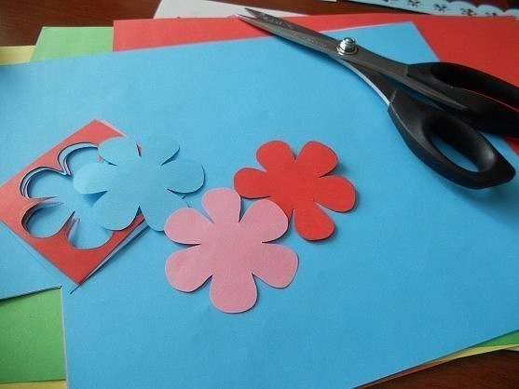](https://ok.ru/dk?cmd=PopLayerPhoto&st.layer.cmd=PopLayerPhotoOuter&st.layer.type=GROUP&st.layer.revNav=off&st.layer.limitedUi=false&st.layer.sphotoIds=852245390388;852245390644;852245390900;852245391156;852245391412;852245391668;852245391924;852245392180;852245392436&st.layer.showNav=on&st.layer.photoAlbumId=57249062780980&st.layer.epm=off&st.layer.photoId=852245391924&st.layer.opl=off&st.layer.navStartPhotoId=852245391924&st.layer.sbd=off&st.cmd=altGroupMain&st.groupId=57249006420020&st.referenceName=chudovospi&st._aid=GroupTopicLayer_openPhotoLayer)

[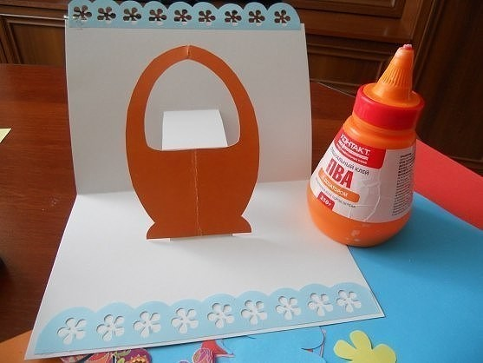](https://ok.ru/dk?cmd=PopLayerPhoto&st.layer.cmd=PopLayerPhotoOuter&st.layer.type=GROUP&st.layer.revNav=off&st.layer.limitedUi=false&st.layer.sphotoIds=852245390388;852245390644;852245390900;852245391156;852245391412;852245391668;852245391924;852245392180;852245392436&st.layer.showNav=on&st.layer.photoAlbumId=57249062780980&st.layer.epm=off&st.layer.photoId=852245392180&st.layer.opl=off&st.layer.navStartPhotoId=852245392180&st.layer.sbd=off&st.cmd=altGroupMain&st.groupId=57249006420020&st.referenceName=chudovospi&st._aid=GroupTopicLayer_openPhotoLayer)

[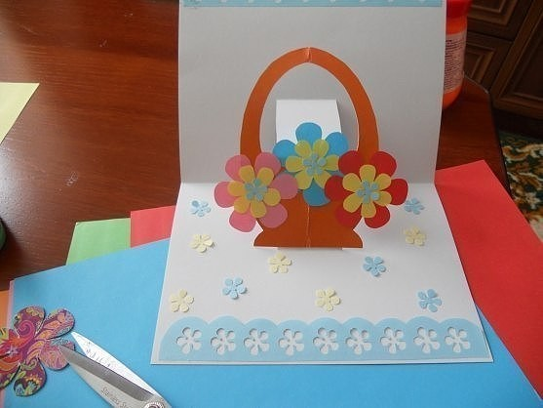](https://ok.ru/dk?cmd=PopLayerPhoto&st.layer.cmd=PopLayerPhotoOuter&st.layer.type=GROUP&st.layer.revNav=off&st.layer.limitedUi=false&st.layer.sphotoIds=852245390388;852245390644;852245390900;852245391156;852245391412;852245391668;852245391924;852245392180;852245392436&st.layer.showNav=on&st.layer.photoAlbumId=57249062780980&st.layer.epm=off&st.layer.photoId=852245392436&st.layer.opl=off&st.layer.navStartPhotoId=852245392436&st.layer.sbd=off&st.cmd=altGroupMain&st.groupId=57249006420020&st.referenceName=chudovospi&st._aid=GroupTopicLayer_openPhotoLayer)