ИДЕИ ДЛЯ ЗИМНЕГО ТВОРЧЕСТВА

[](https://ok.ru/dk?cmd=PopLayerPhoto&st.layer.cmd=PopLayerPhotoOuter&st.layer.type=GROUP&st.layer.revNav=off&st.layer.limitedUi=false&st.layer.closeLayers=off&st.layer.sphotoIds=875520484067;875520484323;875520484579;875520484835;875520485091;875520485347;875520485603;875520485859;875520486115;875520486371&st.layer.showNav=on&st.layer.photoAlbumId=54335204229347&st.layer.epm=off&st.layer.photoId=875520484067&st.layer.opl=off&st.layer.navStartPhotoId=875520484067&st.layer.sbd=off&st.cmd=altGroupMain&st.groupId=54335192826083&st.referenceName=podelkabelka&st._aid=GroupTopicLayer_openPhotoLayer)

[](https://ok.ru/dk?cmd=PopLayerPhoto&st.layer.cmd=PopLayerPhotoOuter&st.layer.type=GROUP&st.layer.revNav=off&st.layer.limitedUi=false&st.layer.closeLayers=off&st.layer.sphotoIds=875520484067;875520484323;875520484579;875520484835;875520485091;875520485347;875520485603;875520485859;875520486115;875520486371&st.layer.showNav=on&st.layer.photoAlbumId=54335204229347&st.layer.epm=off&st.layer.photoId=875520484323&st.layer.opl=off&st.layer.navStartPhotoId=875520484323&st.layer.sbd=off&st.cmd=altGroupMain&st.groupId=54335192826083&st.referenceName=podelkabelka&st._aid=GroupTopicLayer_openPhotoLayer)

[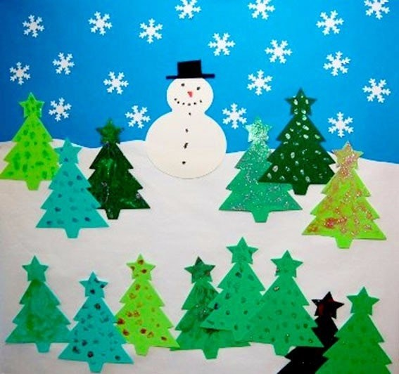](https://ok.ru/dk?cmd=PopLayerPhoto&st.layer.cmd=PopLayerPhotoOuter&st.layer.type=GROUP&st.layer.revNav=off&st.layer.limitedUi=false&st.layer.closeLayers=off&st.layer.sphotoIds=875520484067;875520484323;875520484579;875520484835;875520485091;875520485347;875520485603;875520485859;875520486115;875520486371&st.layer.showNav=on&st.layer.photoAlbumId=54335204229347&st.layer.epm=off&st.layer.photoId=875520484579&st.layer.opl=off&st.layer.navStartPhotoId=875520484579&st.layer.sbd=off&st.cmd=altGroupMain&st.groupId=54335192826083&st.referenceName=podelkabelka&st._aid=GroupTopicLayer_openPhotoLayer)

[](https://ok.ru/dk?cmd=PopLayerPhoto&st.layer.cmd=PopLayerPhotoOuter&st.layer.type=GROUP&st.layer.revNav=off&st.layer.limitedUi=false&st.layer.closeLayers=off&st.layer.sphotoIds=875520484067;875520484323;875520484579;875520484835;875520485091;875520485347;875520485603;875520485859;875520486115;875520486371&st.layer.showNav=on&st.layer.photoAlbumId=54335204229347&st.layer.epm=off&st.layer.photoId=875520484835&st.layer.opl=off&st.layer.navStartPhotoId=875520484835&st.layer.sbd=off&st.cmd=altGroupMain&st.groupId=54335192826083&st.referenceName=podelkabelka&st._aid=GroupTopicLayer_openPhotoLayer)

[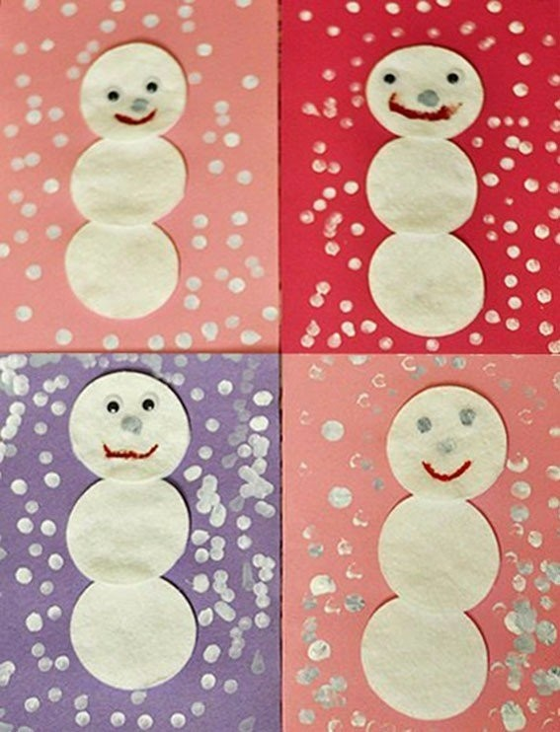](https://ok.ru/dk?cmd=PopLayerPhoto&st.layer.cmd=PopLayerPhotoOuter&st.layer.type=GROUP&st.layer.revNav=off&st.layer.limitedUi=false&st.layer.closeLayers=off&st.layer.sphotoIds=875520484067;875520484323;875520484579;875520484835;875520485091;875520485347;875520485603;875520485859;875520486115;875520486371&st.layer.showNav=on&st.layer.photoAlbumId=54335204229347&st.layer.epm=off&st.layer.photoId=875520485091&st.layer.opl=off&st.layer.navStartPhotoId=875520485091&st.layer.sbd=off&st.cmd=altGroupMain&st.groupId=54335192826083&st.referenceName=podelkabelka&st._aid=GroupTopicLayer_openPhotoLayer)

[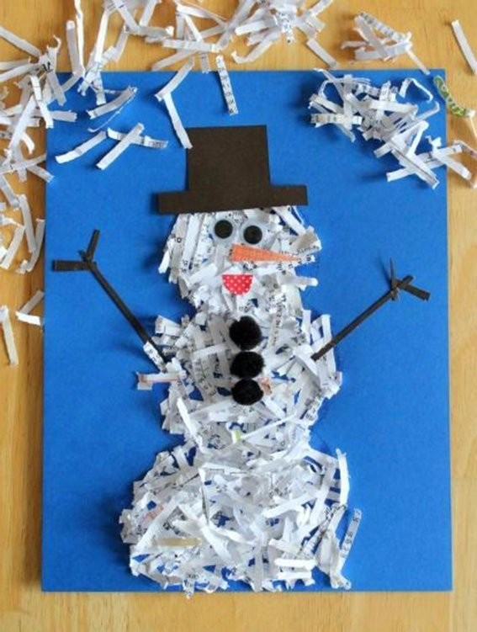](https://ok.ru/dk?cmd=PopLayerPhoto&st.layer.cmd=PopLayerPhotoOuter&st.layer.type=GROUP&st.layer.revNav=off&st.layer.limitedUi=false&st.layer.closeLayers=off&st.layer.sphotoIds=875520484067;875520484323;875520484579;875520484835;875520485091;875520485347;875520485603;875520485859;875520486115;875520486371&st.layer.showNav=on&st.layer.photoAlbumId=54335204229347&st.layer.epm=off&st.layer.photoId=875520485347&st.layer.opl=off&st.layer.navStartPhotoId=875520485347&st.layer.sbd=off&st.cmd=altGroupMain&st.groupId=54335192826083&st.referenceName=podelkabelka&st._aid=GroupTopicLayer_openPhotoLayer)

[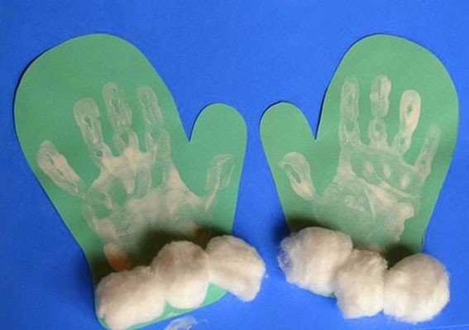](https://ok.ru/dk?cmd=PopLayerPhoto&st.layer.cmd=PopLayerPhotoOuter&st.layer.type=GROUP&st.layer.revNav=off&st.layer.limitedUi=false&st.layer.closeLayers=off&st.layer.sphotoIds=875520484067;875520484323;875520484579;875520484835;875520485091;875520485347;875520485603;875520485859;875520486115;875520486371&st.layer.showNav=on&st.layer.photoAlbumId=54335204229347&st.layer.epm=off&st.layer.photoId=875520485603&st.layer.opl=off&st.layer.navStartPhotoId=875520485603&st.layer.sbd=off&st.cmd=altGroupMain&st.groupId=54335192826083&st.referenceName=podelkabelka&st._aid=GroupTopicLayer_openPhotoLayer)

[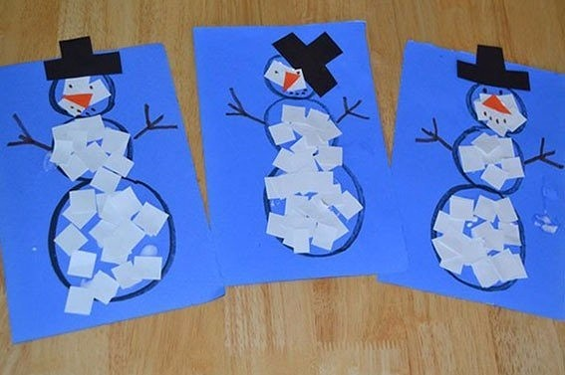](https://ok.ru/dk?cmd=PopLayerPhoto&st.layer.cmd=PopLayerPhotoOuter&st.layer.type=GROUP&st.layer.revNav=off&st.layer.limitedUi=false&st.layer.closeLayers=off&st.layer.sphotoIds=875520484067;875520484323;875520484579;875520484835;875520485091;875520485347;875520485603;875520485859;875520486115;875520486371&st.layer.showNav=on&st.layer.photoAlbumId=54335204229347&st.layer.epm=off&st.layer.photoId=875520485859&st.layer.opl=off&st.layer.navStartPhotoId=875520485859&st.layer.sbd=off&st.cmd=altGroupMain&st.groupId=54335192826083&st.referenceName=podelkabelka&st._aid=GroupTopicLayer_openPhotoLayer)

[](https://ok.ru/dk?cmd=PopLayerPhoto&st.layer.cmd=PopLayerPhotoOuter&st.layer.type=GROUP&st.layer.revNav=off&st.layer.limitedUi=false&st.layer.closeLayers=off&st.layer.sphotoIds=875520484067;875520484323;875520484579;875520484835;875520485091;875520485347;875520485603;875520485859;875520486115;875520486371&st.layer.showNav=on&st.layer.photoAlbumId=54335204229347&st.layer.epm=off&st.layer.photoId=875520486115&st.layer.opl=off&st.layer.navStartPhotoId=875520486115&st.layer.sbd=off&st.cmd=altGroupMain&st.groupId=54335192826083&st.referenceName=podelkabelka&st._aid=GroupTopicLayer_openPhotoLayer)

[](https://ok.ru/dk?cmd=PopLayerPhoto&st.layer.cmd=PopLayerPhotoOuter&st.layer.type=GROUP&st.layer.revNav=off&st.layer.limitedUi=false&st.layer.closeLayers=off&st.layer.sphotoIds=875520484067;875520484323;875520484579;875520484835;875520485091;875520485347;875520485603;875520485859;875520486115;875520486371&st.layer.showNav=on&st.layer.photoAlbumId=54335204229347&st.layer.epm=off&st.layer.photoId=875520486371&st.layer.opl=off&st.layer.navStartPhotoId=875520486371&st.layer.sbd=off&st.cmd=altGroupMain&st.groupId=54335192826083&st.referenceName=podelkabelka&st._aid=GroupTopicLayer_openPhotoLayer)

