***Бумажные***

***цветы.***

***\*\*\*\*\*\*\*\*\*\****

***Идеи для творчества***

[](https://ok.ru/dk?cmd=PopLayerPhoto&st.layer.cmd=PopLayerPhotoOuter&st.layer.type=GROUP&st.layer.revNav=off&st.layer.limitedUi=false&st.layer.closeLayers=off&st.layer.sphotoIds=877845464552;877845464808;877845465064;877845465320;877845465576;877845465832;877845466088;877845466344&st.layer.showNav=on&st.layer.photoAlbumId=54085849317608&st.layer.epm=off&st.layer.photoId=877845464552&st.layer.opl=off&st.layer.navStartPhotoId=877845464552&st.layer.sbd=off&st.cmd=altGroupMain&st.groupId=54085840011496&st.referenceName=group54085840011496&st._aid=GroupTopicLayer_openPhotoLayer)

[](https://ok.ru/dk?cmd=PopLayerPhoto&st.layer.cmd=PopLayerPhotoOuter&st.layer.type=GROUP&st.layer.revNav=off&st.layer.limitedUi=false&st.layer.closeLayers=off&st.layer.sphotoIds=877845464552;877845464808;877845465064;877845465320;877845465576;877845465832;877845466088;877845466344&st.layer.showNav=on&st.layer.photoAlbumId=54085849317608&st.layer.epm=off&st.layer.photoId=877845464808&st.layer.opl=off&st.layer.navStartPhotoId=877845464808&st.layer.sbd=off&st.cmd=altGroupMain&st.groupId=54085840011496&st.referenceName=group54085840011496&st._aid=GroupTopicLayer_openPhotoLayer)

[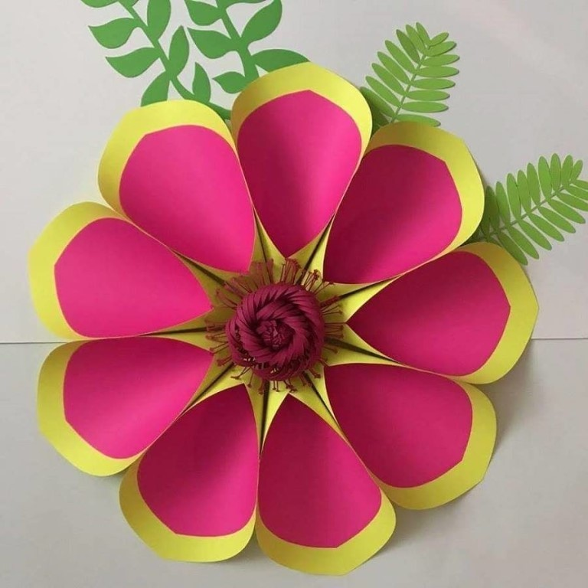](https://ok.ru/dk?cmd=PopLayerPhoto&st.layer.cmd=PopLayerPhotoOuter&st.layer.type=GROUP&st.layer.revNav=off&st.layer.limitedUi=false&st.layer.closeLayers=off&st.layer.sphotoIds=877845464552;877845464808;877845465064;877845465320;877845465576;877845465832;877845466088;877845466344&st.layer.showNav=on&st.layer.photoAlbumId=54085849317608&st.layer.epm=off&st.layer.photoId=877845465064&st.layer.opl=off&st.layer.navStartPhotoId=877845465064&st.layer.sbd=off&st.cmd=altGroupMain&st.groupId=54085840011496&st.referenceName=group54085840011496&st._aid=GroupTopicLayer_openPhotoLayer)

[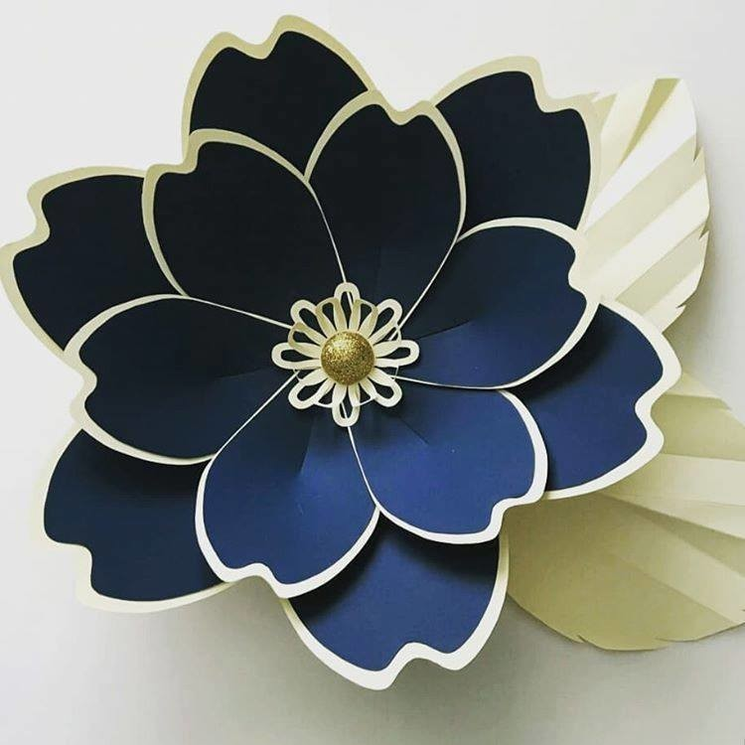](https://ok.ru/dk?cmd=PopLayerPhoto&st.layer.cmd=PopLayerPhotoOuter&st.layer.type=GROUP&st.layer.revNav=off&st.layer.limitedUi=false&st.layer.closeLayers=off&st.layer.sphotoIds=877845464552;877845464808;877845465064;877845465320;877845465576;877845465832;877845466088;877845466344&st.layer.showNav=on&st.layer.photoAlbumId=54085849317608&st.layer.epm=off&st.layer.photoId=877845465320&st.layer.opl=off&st.layer.navStartPhotoId=877845465320&st.layer.sbd=off&st.cmd=altGroupMain&st.groupId=54085840011496&st.referenceName=group54085840011496&st._aid=GroupTopicLayer_openPhotoLayer)

[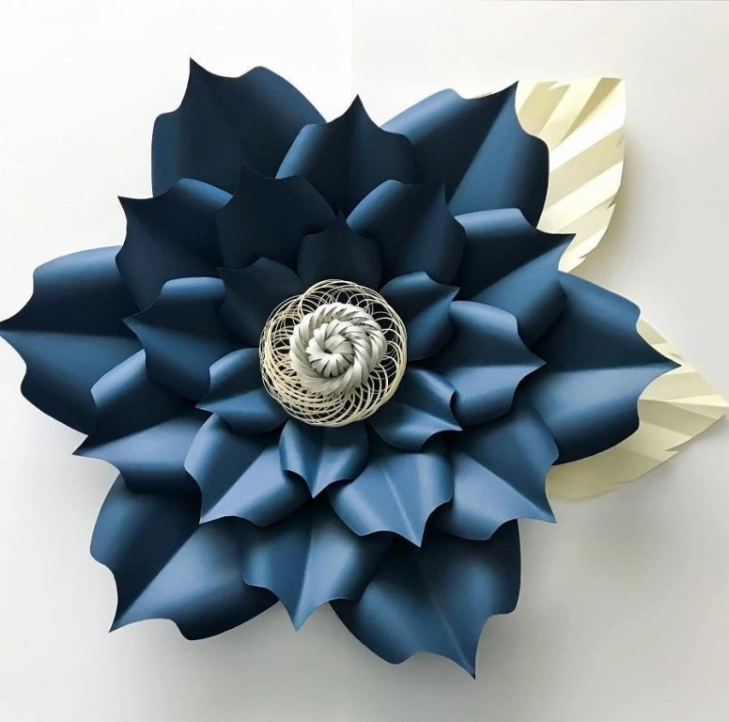](https://ok.ru/dk?cmd=PopLayerPhoto&st.layer.cmd=PopLayerPhotoOuter&st.layer.type=GROUP&st.layer.revNav=off&st.layer.limitedUi=false&st.layer.closeLayers=off&st.layer.sphotoIds=877845464552;877845464808;877845465064;877845465320;877845465576;877845465832;877845466088;877845466344&st.layer.showNav=on&st.layer.photoAlbumId=54085849317608&st.layer.epm=off&st.layer.photoId=877845465576&st.layer.opl=off&st.layer.navStartPhotoId=877845465576&st.layer.sbd=off&st.cmd=altGroupMain&st.groupId=54085840011496&st.referenceName=group54085840011496&st._aid=GroupTopicLayer_openPhotoLayer)

[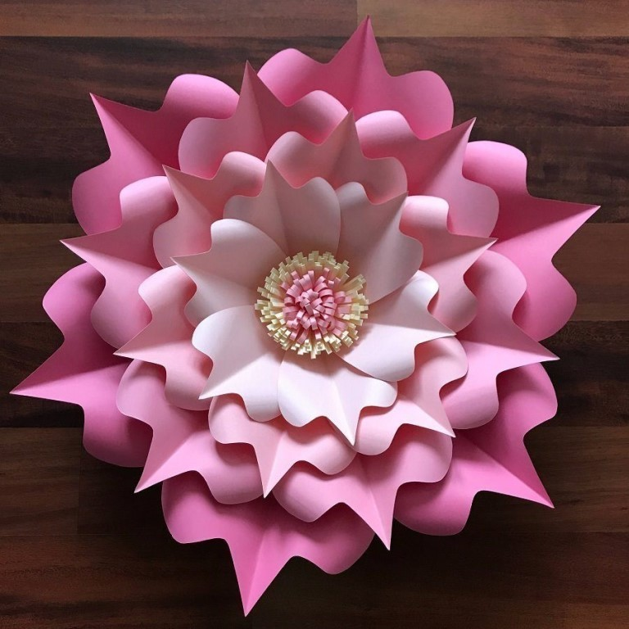](https://ok.ru/dk?cmd=PopLayerPhoto&st.layer.cmd=PopLayerPhotoOuter&st.layer.type=GROUP&st.layer.revNav=off&st.layer.limitedUi=false&st.layer.closeLayers=off&st.layer.sphotoIds=877845464552;877845464808;877845465064;877845465320;877845465576;877845465832;877845466088;877845466344&st.layer.showNav=on&st.layer.photoAlbumId=54085849317608&st.layer.epm=off&st.layer.photoId=877845465832&st.layer.opl=off&st.layer.navStartPhotoId=877845465832&st.layer.sbd=off&st.cmd=altGroupMain&st.groupId=54085840011496&st.referenceName=group54085840011496&st._aid=GroupTopicLayer_openPhotoLayer)

[](https://ok.ru/dk?cmd=PopLayerPhoto&st.layer.cmd=PopLayerPhotoOuter&st.layer.type=GROUP&st.layer.revNav=off&st.layer.limitedUi=false&st.layer.closeLayers=off&st.layer.sphotoIds=877845464552;877845464808;877845465064;877845465320;877845465576;877845465832;877845466088;877845466344&st.layer.showNav=on&st.layer.photoAlbumId=54085849317608&st.layer.epm=off&st.layer.photoId=877845466088&st.layer.opl=off&st.layer.navStartPhotoId=877845466088&st.layer.sbd=off&st.cmd=altGroupMain&st.groupId=54085840011496&st.referenceName=group54085840011496&st._aid=GroupTopicLayer_openPhotoLayer)

[](https://ok.ru/dk?cmd=PopLayerPhoto&st.layer.cmd=PopLayerPhotoOuter&st.layer.type=GROUP&st.layer.revNav=off&st.layer.limitedUi=false&st.layer.closeLayers=off&st.layer.sphotoIds=877845464552;877845464808;877845465064;877845465320;877845465576;877845465832;877845466088;877845466344&st.layer.showNav=on&st.layer.photoAlbumId=54085849317608&st.layer.epm=off&st.layer.photoId=877845466344&st.layer.opl=off&st.layer.navStartPhotoId=877845466344&st.layer.sbd=off&st.cmd=altGroupMain&st.groupId=54085840011496&st.referenceName=group54085840011496&st._aid=GroupTopicLayer_openPhotoLayer)