**ОСЕНЬ В ДЕТСКОМ САДУ**

[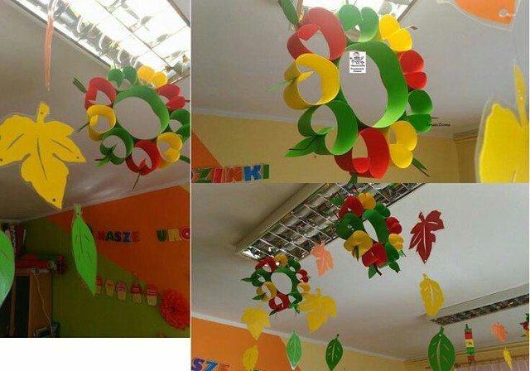](https://ok.ru/dk?cmd=PopLayerPhoto&st.layer.cmd=PopLayerPhotoOuter&st.layer.type=GROUP&st.layer.revNav=off&st.layer.limitedUi=false&st.layer.sphotoIds=858769753338;858770692090;858769752826;858769753594;858770696698;858769753082;858769753850;858769754106;858770720250;858770718714;858770717434;858769754362;858769754618;858769754874;858769755130;858769755386;858769755642&st.layer.showNav=on&st.layer.photoAlbumId=52761215107322&st.layer.epm=off&st.layer.photoId=858769753338&st.layer.opl=off&st.layer.navStartPhotoId=858769753338&st.layer.sbd=off&st.cmd=altGroupMain&st.groupId=52794207502538&st.referenceName=vsedlyarab&st._aid=GroupTopicLayer_openPhotoLayer)

[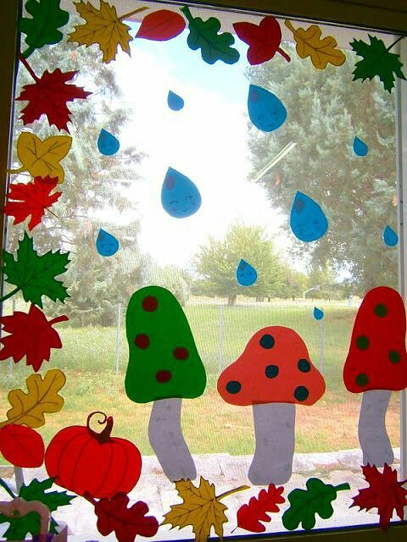](https://ok.ru/dk?cmd=PopLayerPhoto&st.layer.cmd=PopLayerPhotoOuter&st.layer.type=GROUP&st.layer.revNav=off&st.layer.limitedUi=false&st.layer.sphotoIds=858769753338;858770692090;858769752826;858769753594;858770696698;858769753082;858769753850;858769754106;858770720250;858770718714;858770717434;858769754362;858769754618;858769754874;858769755130;858769755386;858769755642&st.layer.showNav=on&st.layer.photoAlbumId=52761215107322&st.layer.epm=off&st.layer.photoId=858770692090&st.layer.opl=off&st.layer.navStartPhotoId=858770692090&st.layer.sbd=off&st.cmd=altGroupMain&st.groupId=52794207502538&st.referenceName=vsedlyarab&st._aid=GroupTopicLayer_openPhotoLayer)

[](https://ok.ru/dk?cmd=PopLayerPhoto&st.layer.cmd=PopLayerPhotoOuter&st.layer.type=GROUP&st.layer.revNav=off&st.layer.limitedUi=false&st.layer.sphotoIds=858769753338;858770692090;858769752826;858769753594;858770696698;858769753082;858769753850;858769754106;858770720250;858770718714;858770717434;858769754362;858769754618;858769754874;858769755130;858769755386;858769755642&st.layer.showNav=on&st.layer.photoAlbumId=52761215107322&st.layer.epm=off&st.layer.photoId=858769752826&st.layer.opl=off&st.layer.navStartPhotoId=858769752826&st.layer.sbd=off&st.cmd=altGroupMain&st.groupId=52794207502538&st.referenceName=vsedlyarab&st._aid=GroupTopicLayer_openPhotoLayer)

[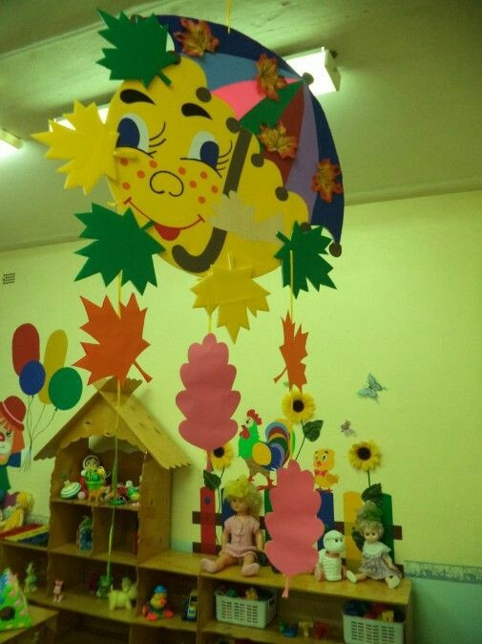](https://ok.ru/dk?cmd=PopLayerPhoto&st.layer.cmd=PopLayerPhotoOuter&st.layer.type=GROUP&st.layer.revNav=off&st.layer.limitedUi=false&st.layer.sphotoIds=858769753338;858770692090;858769752826;858769753594;858770696698;858769753082;858769753850;858769754106;858770720250;858770718714;858770717434;858769754362;858769754618;858769754874;858769755130;858769755386;858769755642&st.layer.showNav=on&st.layer.photoAlbumId=52761215107322&st.layer.epm=off&st.layer.photoId=858769753594&st.layer.opl=off&st.layer.navStartPhotoId=858769753594&st.layer.sbd=off&st.cmd=altGroupMain&st.groupId=52794207502538&st.referenceName=vsedlyarab&st._aid=GroupTopicLayer_openPhotoLayer)

[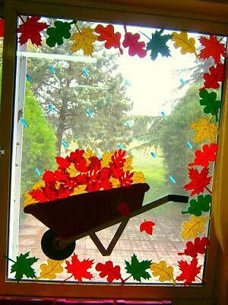](https://ok.ru/dk?cmd=PopLayerPhoto&st.layer.cmd=PopLayerPhotoOuter&st.layer.type=GROUP&st.layer.revNav=off&st.layer.limitedUi=false&st.layer.sphotoIds=858769753338;858770692090;858769752826;858769753594;858770696698;858769753082;858769753850;858769754106;858770720250;858770718714;858770717434;858769754362;858769754618;858769754874;858769755130;858769755386;858769755642&st.layer.showNav=on&st.layer.photoAlbumId=52761215107322&st.layer.epm=off&st.layer.photoId=858770696698&st.layer.opl=off&st.layer.navStartPhotoId=858770696698&st.layer.sbd=off&st.cmd=altGroupMain&st.groupId=52794207502538&st.referenceName=vsedlyarab&st._aid=GroupTopicLayer_openPhotoLayer)

[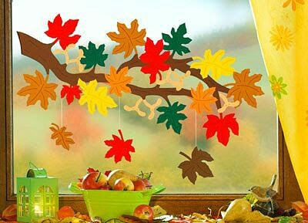](https://ok.ru/dk?cmd=PopLayerPhoto&st.layer.cmd=PopLayerPhotoOuter&st.layer.type=GROUP&st.layer.revNav=off&st.layer.limitedUi=false&st.layer.sphotoIds=858769753338;858770692090;858769752826;858769753594;858770696698;858769753082;858769753850;858769754106;858770720250;858770718714;858770717434;858769754362;858769754618;858769754874;858769755130;858769755386;858769755642&st.layer.showNav=on&st.layer.photoAlbumId=52761215107322&st.layer.epm=off&st.layer.photoId=858769753082&st.layer.opl=off&st.layer.navStartPhotoId=858769753082&st.layer.sbd=off&st.cmd=altGroupMain&st.groupId=52794207502538&st.referenceName=vsedlyarab&st._aid=GroupTopicLayer_openPhotoLayer)

[](https://ok.ru/dk?cmd=PopLayerPhoto&st.layer.cmd=PopLayerPhotoOuter&st.layer.type=GROUP&st.layer.revNav=off&st.layer.limitedUi=false&st.layer.sphotoIds=858769753338;858770692090;858769752826;858769753594;858770696698;858769753082;858769753850;858769754106;858770720250;858770718714;858770717434;858769754362;858769754618;858769754874;858769755130;858769755386;858769755642&st.layer.showNav=on&st.layer.photoAlbumId=52761215107322&st.layer.epm=off&st.layer.photoId=858769753850&st.layer.opl=off&st.layer.navStartPhotoId=858769753850&st.layer.sbd=off&st.cmd=altGroupMain&st.groupId=52794207502538&st.referenceName=vsedlyarab&st._aid=GroupTopicLayer_openPhotoLayer)

[](https://ok.ru/dk?cmd=PopLayerPhoto&st.layer.cmd=PopLayerPhotoOuter&st.layer.type=GROUP&st.layer.revNav=off&st.layer.limitedUi=false&st.layer.sphotoIds=858769753338;858770692090;858769752826;858769753594;858770696698;858769753082;858769753850;858769754106;858770720250;858770718714;858770717434;858769754362;858769754618;858769754874;858769755130;858769755386;858769755642&st.layer.showNav=on&st.layer.photoAlbumId=52761215107322&st.layer.epm=off&st.layer.photoId=858769754106&st.layer.opl=off&st.layer.navStartPhotoId=858769754106&st.layer.sbd=off&st.cmd=altGroupMain&st.groupId=52794207502538&st.referenceName=vsedlyarab&st._aid=GroupTopicLayer_openPhotoLayer)

[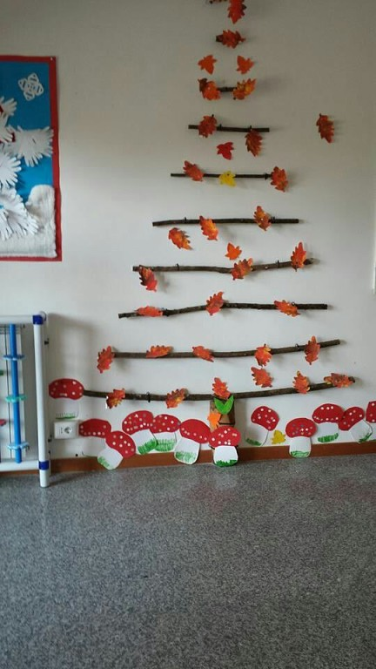](https://ok.ru/dk?cmd=PopLayerPhoto&st.layer.cmd=PopLayerPhotoOuter&st.layer.type=GROUP&st.layer.revNav=off&st.layer.limitedUi=false&st.layer.sphotoIds=858769753338;858770692090;858769752826;858769753594;858770696698;858769753082;858769753850;858769754106;858770720250;858770718714;858770717434;858769754362;858769754618;858769754874;858769755130;858769755386;858769755642&st.layer.showNav=on&st.layer.photoAlbumId=52761215107322&st.layer.epm=off&st.layer.photoId=858770720250&st.layer.opl=off&st.layer.navStartPhotoId=858770720250&st.layer.sbd=off&st.cmd=altGroupMain&st.groupId=52794207502538&st.referenceName=vsedlyarab&st._aid=GroupTopicLayer_openPhotoLayer)

[](https://ok.ru/dk?cmd=PopLayerPhoto&st.layer.cmd=PopLayerPhotoOuter&st.layer.type=GROUP&st.layer.revNav=off&st.layer.limitedUi=false&st.layer.sphotoIds=858769753338;858770692090;858769752826;858769753594;858770696698;858769753082;858769753850;858769754106;858770720250;858770718714;858770717434;858769754362;858769754618;858769754874;858769755130;858769755386;858769755642&st.layer.showNav=on&st.layer.photoAlbumId=52761215107322&st.layer.epm=off&st.layer.photoId=858769755642&st.layer.opl=off&st.layer.navStartPhotoId=858769755642&st.layer.sbd=off&st.cmd=altGroupMain&st.groupId=52794207502538&st.referenceName=vsedlyarab&st._aid=GroupTopicLayer_openPhotoLayer)[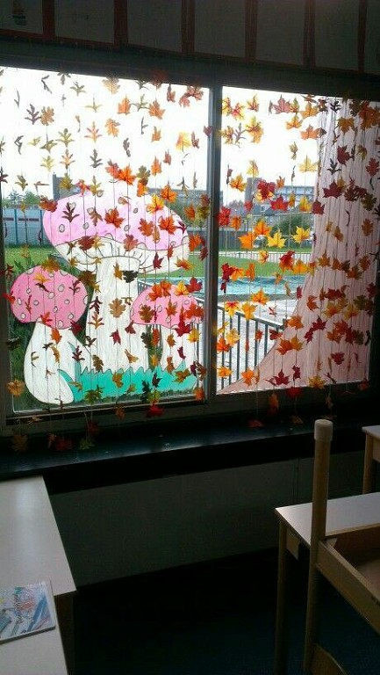](https://ok.ru/dk?cmd=PopLayerPhoto&st.layer.cmd=PopLayerPhotoOuter&st.layer.type=GROUP&st.layer.revNav=off&st.layer.limitedUi=false&st.layer.sphotoIds=858769753338;858770692090;858769752826;858769753594;858770696698;858769753082;858769753850;858769754106;858770720250;858770718714;858770717434;858769754362;858769754618;858769754874;858769755130;858769755386;858769755642&st.layer.showNav=on&st.layer.photoAlbumId=52761215107322&st.layer.epm=off&st.layer.photoId=858770718714&st.layer.opl=off&st.layer.navStartPhotoId=858770718714&st.layer.sbd=off&st.cmd=altGroupMain&st.groupId=52794207502538&st.referenceName=vsedlyarab&st._aid=GroupTopicLayer_openPhotoLayer)

[](https://ok.ru/dk?cmd=PopLayerPhoto&st.layer.cmd=PopLayerPhotoOuter&st.layer.type=GROUP&st.layer.revNav=off&st.layer.limitedUi=false&st.layer.sphotoIds=858769753338;858770692090;858769752826;858769753594;858770696698;858769753082;858769753850;858769754106;858770720250;858770718714;858770717434;858769754362;858769754618;858769754874;858769755130;858769755386;858769755642&st.layer.showNav=on&st.layer.photoAlbumId=52761215107322&st.layer.epm=off&st.layer.photoId=858770717434&st.layer.opl=off&st.layer.navStartPhotoId=858770717434&st.layer.sbd=off&st.cmd=altGroupMain&st.groupId=52794207502538&st.referenceName=vsedlyarab&st._aid=GroupTopicLayer_openPhotoLayer)

[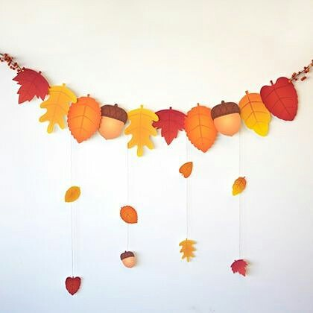](https://ok.ru/dk?cmd=PopLayerPhoto&st.layer.cmd=PopLayerPhotoOuter&st.layer.type=GROUP&st.layer.revNav=off&st.layer.limitedUi=false&st.layer.sphotoIds=858769753338;858770692090;858769752826;858769753594;858770696698;858769753082;858769753850;858769754106;858770720250;858770718714;858770717434;858769754362;858769754618;858769754874;858769755130;858769755386;858769755642&st.layer.showNav=on&st.layer.photoAlbumId=52761215107322&st.layer.epm=off&st.layer.photoId=858769754362&st.layer.opl=off&st.layer.navStartPhotoId=858769754362&st.layer.sbd=off&st.cmd=altGroupMain&st.groupId=52794207502538&st.referenceName=vsedlyarab&st._aid=GroupTopicLayer_openPhotoLayer)

[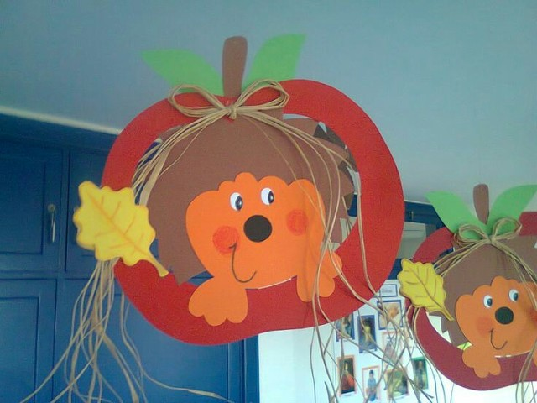](https://ok.ru/dk?cmd=PopLayerPhoto&st.layer.cmd=PopLayerPhotoOuter&st.layer.type=GROUP&st.layer.revNav=off&st.layer.limitedUi=false&st.layer.sphotoIds=858769753338;858770692090;858769752826;858769753594;858770696698;858769753082;858769753850;858769754106;858770720250;858770718714;858770717434;858769754362;858769754618;858769754874;858769755130;858769755386;858769755642&st.layer.showNav=on&st.layer.photoAlbumId=52761215107322&st.layer.epm=off&st.layer.photoId=858769754618&st.layer.opl=off&st.layer.navStartPhotoId=858769754618&st.layer.sbd=off&st.cmd=altGroupMain&st.groupId=52794207502538&st.referenceName=vsedlyarab&st._aid=GroupTopicLayer_openPhotoLayer)

[](https://ok.ru/dk?cmd=PopLayerPhoto&st.layer.cmd=PopLayerPhotoOuter&st.layer.type=GROUP&st.layer.revNav=off&st.layer.limitedUi=false&st.layer.sphotoIds=858769753338;858770692090;858769752826;858769753594;858770696698;858769753082;858769753850;858769754106;858770720250;858770718714;858770717434;858769754362;858769754618;858769754874;858769755130;858769755386;858769755642&st.layer.showNav=on&st.layer.photoAlbumId=52761215107322&st.layer.epm=off&st.layer.photoId=858769754874&st.layer.opl=off&st.layer.navStartPhotoId=858769754874&st.layer.sbd=off&st.cmd=altGroupMain&st.groupId=52794207502538&st.referenceName=vsedlyarab&st._aid=GroupTopicLayer_openPhotoLayer)

[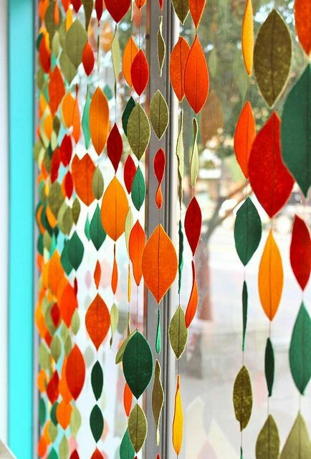](https://ok.ru/dk?cmd=PopLayerPhoto&st.layer.cmd=PopLayerPhotoOuter&st.layer.type=GROUP&st.layer.revNav=off&st.layer.limitedUi=false&st.layer.sphotoIds=858769753338;858770692090;858769752826;858769753594;858770696698;858769753082;858769753850;858769754106;858770720250;858770718714;858770717434;858769754362;858769754618;858769754874;858769755130;858769755386;858769755642&st.layer.showNav=on&st.layer.photoAlbumId=52761215107322&st.layer.epm=off&st.layer.photoId=858769755130&st.layer.opl=off&st.layer.navStartPhotoId=858769755130&st.layer.sbd=off&st.cmd=altGroupMain&st.groupId=52794207502538&st.referenceName=vsedlyarab&st._aid=GroupTopicLayer_openPhotoLayer)

[](https://ok.ru/dk?cmd=PopLayerPhoto&st.layer.cmd=PopLayerPhotoOuter&st.layer.type=GROUP&st.layer.revNav=off&st.layer.limitedUi=false&st.layer.sphotoIds=858769753338;858770692090;858769752826;858769753594;858770696698;858769753082;858769753850;858769754106;858770720250;858770718714;858770717434;858769754362;858769754618;858769754874;858769755130;858769755386;858769755642&st.layer.showNav=on&st.layer.photoAlbumId=52761215107322&st.layer.epm=off&st.layer.photoId=858769755386&st.layer.opl=off&st.layer.navStartPhotoId=858769755386&st.layer.sbd=off&st.cmd=altGroupMain&st.groupId=52794207502538&st.referenceName=vsedlyarab&st._aid=GroupTopicLayer_openPhotoLayer)