***ОБЪЁМНЫЕ АППЛИКАЦИИ ИЗ БУМАГИ***

[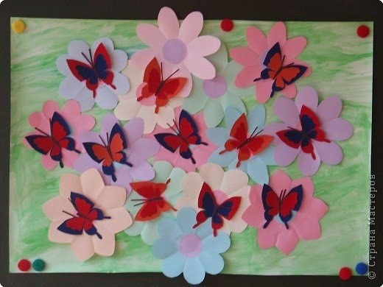](https://ok.ru/dk?cmd=PopLayerPhoto&st.layer.cmd=PopLayerPhotoOuter&st.layer.type=GROUP&st.layer.revNav=off&st.layer.limitedUi=false&st.layer.sphotoIds=852535251018;852535250762;852535250506;852535250250;852535249994;852535249738;852535249482;852535249226&st.layer.showNav=on&st.layer.photoAlbumId=52556583141450&st.layer.epm=off&st.layer.photoId=852535251018&st.layer.opl=off&st.layer.navStartPhotoId=852535251018&st.layer.sbd=off&st.cmd=altGroupMain&st.groupId=57648070393893&st.referenceName=papkipere&st._aid=GroupTopicLayer_openPhotoLayer)

[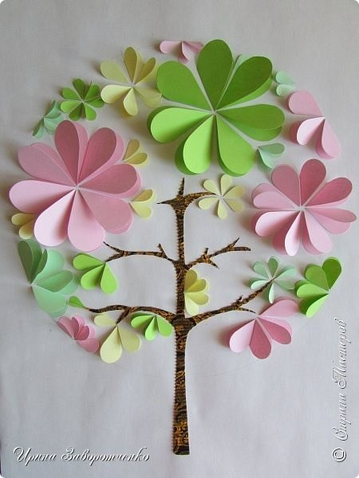](https://ok.ru/dk?cmd=PopLayerPhoto&st.layer.cmd=PopLayerPhotoOuter&st.layer.type=GROUP&st.layer.revNav=off&st.layer.limitedUi=false&st.layer.sphotoIds=852535251018;852535250762;852535250506;852535250250;852535249994;852535249738;852535249482;852535249226&st.layer.showNav=on&st.layer.photoAlbumId=52556583141450&st.layer.epm=off&st.layer.photoId=852535250762&st.layer.opl=off&st.layer.navStartPhotoId=852535250762&st.layer.sbd=off&st.cmd=altGroupMain&st.groupId=57648070393893&st.referenceName=papkipere&st._aid=GroupTopicLayer_openPhotoLayer)

[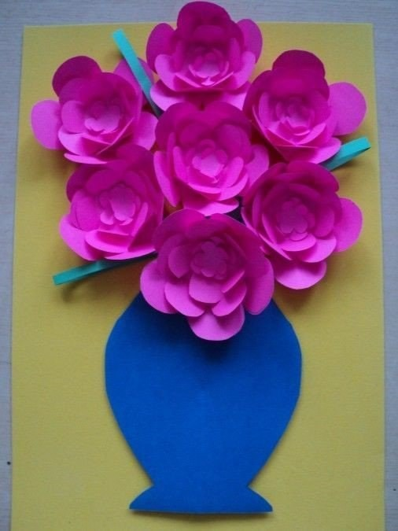](https://ok.ru/dk?cmd=PopLayerPhoto&st.layer.cmd=PopLayerPhotoOuter&st.layer.type=GROUP&st.layer.revNav=off&st.layer.limitedUi=false&st.layer.sphotoIds=852535251018;852535250762;852535250506;852535250250;852535249994;852535249738;852535249482;852535249226&st.layer.showNav=on&st.layer.photoAlbumId=52556583141450&st.layer.epm=off&st.layer.photoId=852535250506&st.layer.opl=off&st.layer.navStartPhotoId=852535250506&st.layer.sbd=off&st.cmd=altGroupMain&st.groupId=57648070393893&st.referenceName=papkipere&st._aid=GroupTopicLayer_openPhotoLayer)

[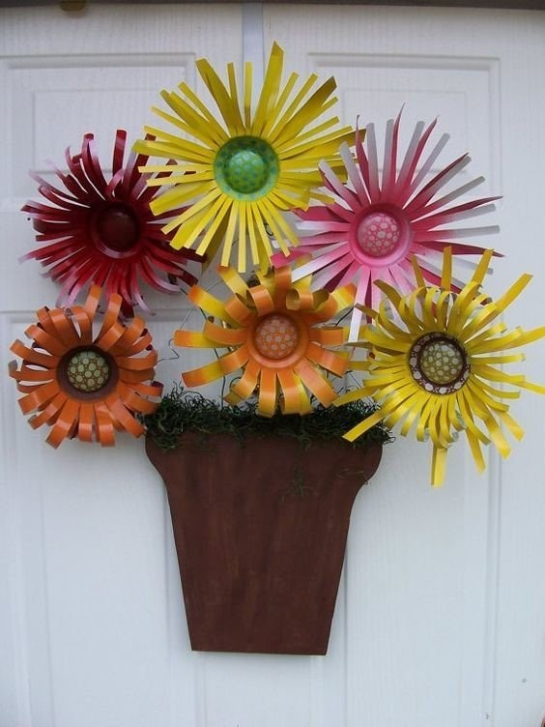](https://ok.ru/dk?cmd=PopLayerPhoto&st.layer.cmd=PopLayerPhotoOuter&st.layer.type=GROUP&st.layer.revNav=off&st.layer.limitedUi=false&st.layer.sphotoIds=852535251018;852535250762;852535250506;852535250250;852535249994;852535249738;852535249482;852535249226&st.layer.showNav=on&st.layer.photoAlbumId=52556583141450&st.layer.epm=off&st.layer.photoId=852535250250&st.layer.opl=off&st.layer.navStartPhotoId=852535250250&st.layer.sbd=off&st.cmd=altGroupMain&st.groupId=57648070393893&st.referenceName=papkipere&st._aid=GroupTopicLayer_openPhotoLayer)

[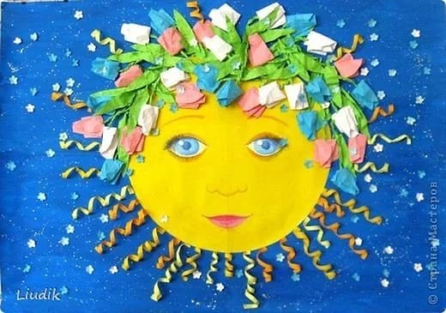](https://ok.ru/dk?cmd=PopLayerPhoto&st.layer.cmd=PopLayerPhotoOuter&st.layer.type=GROUP&st.layer.revNav=off&st.layer.limitedUi=false&st.layer.sphotoIds=852535251018;852535250762;852535250506;852535250250;852535249994;852535249738;852535249482;852535249226&st.layer.showNav=on&st.layer.photoAlbumId=52556583141450&st.layer.epm=off&st.layer.photoId=852535249994&st.layer.opl=off&st.layer.navStartPhotoId=852535249994&st.layer.sbd=off&st.cmd=altGroupMain&st.groupId=57648070393893&st.referenceName=papkipere&st._aid=GroupTopicLayer_openPhotoLayer)

[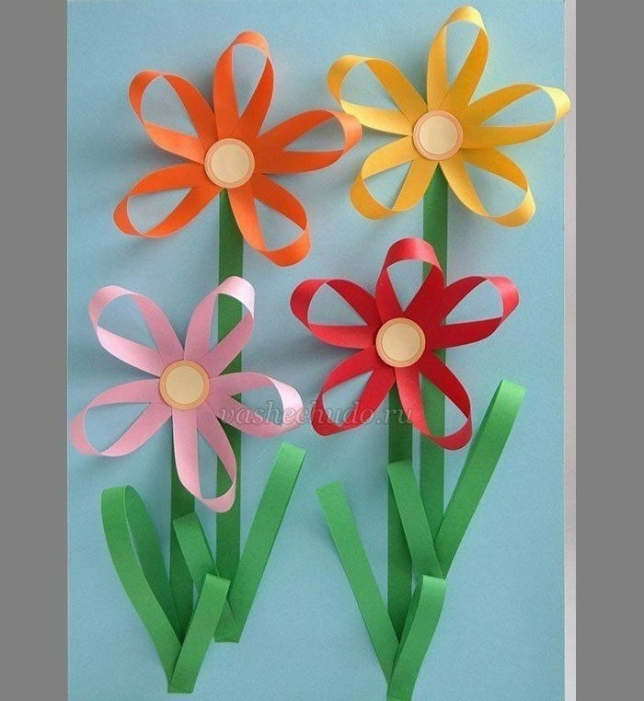](https://ok.ru/dk?cmd=PopLayerPhoto&st.layer.cmd=PopLayerPhotoOuter&st.layer.type=GROUP&st.layer.revNav=off&st.layer.limitedUi=false&st.layer.sphotoIds=852535251018;852535250762;852535250506;852535250250;852535249994;852535249738;852535249482;852535249226&st.layer.showNav=on&st.layer.photoAlbumId=52556583141450&st.layer.epm=off&st.layer.photoId=852535249738&st.layer.opl=off&st.layer.navStartPhotoId=852535249738&st.layer.sbd=off&st.cmd=altGroupMain&st.groupId=57648070393893&st.referenceName=papkipere&st._aid=GroupTopicLayer_openPhotoLayer)

[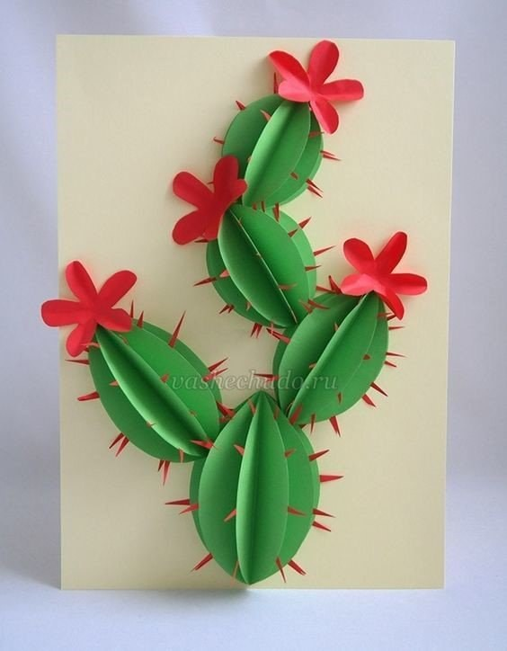](https://ok.ru/dk?cmd=PopLayerPhoto&st.layer.cmd=PopLayerPhotoOuter&st.layer.type=GROUP&st.layer.revNav=off&st.layer.limitedUi=false&st.layer.sphotoIds=852535251018;852535250762;852535250506;852535250250;852535249994;852535249738;852535249482;852535249226&st.layer.showNav=on&st.layer.photoAlbumId=52556583141450&st.layer.epm=off&st.layer.photoId=852535249482&st.layer.opl=off&st.layer.navStartPhotoId=852535249482&st.layer.sbd=off&st.cmd=altGroupMain&st.groupId=57648070393893&st.referenceName=papkipere&st._aid=GroupTopicLayer_openPhotoLayer)

[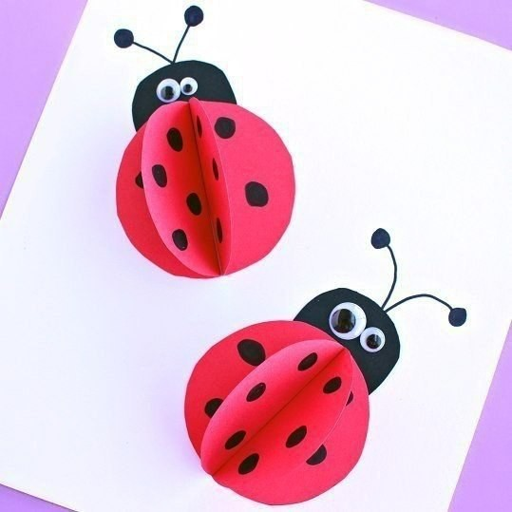](https://ok.ru/dk?cmd=PopLayerPhoto&st.layer.cmd=PopLayerPhotoOuter&st.layer.type=GROUP&st.layer.revNav=off&st.layer.limitedUi=false&st.layer.sphotoIds=852535251018;852535250762;852535250506;852535250250;852535249994;852535249738;852535249482;852535249226&st.layer.showNav=on&st.layer.photoAlbumId=52556583141450&st.layer.epm=off&st.layer.photoId=852535249226&st.layer.opl=off&st.layer.navStartPhotoId=852535249226&st.layer.sbd=off&st.cmd=altGroupMain&st.groupId=57648070393893&st.referenceName=papkipere&st._aid=GroupTopicLayer_openPhotoLayer)