[](https://ok.ru/dk?cmd=PopLayerPhoto&st.layer.cmd=PopLayerPhotoOuter&st.layer.type=GROUP&st.layer.revNav=off&st.layer.limitedUi=false&st.layer.closeLayers=off&st.layer.sphotoIds=889162496767%3B889162497023%3B889162497279%3B889162497535%3B889162497791&st.layer.showNav=on&st.layer.photoAlbumId=55466577756415&st.layer.epm=off&st.layer.photoId=889162496767&st.layer.wasRedirect%2C=off&st.layer.opl=off&st.layer.navStartPhotoId=889162496767&st.layer.navStartAlbumId%2C=55466577756415&st.layer.sbd=off&st.cmd=altGroupForum&st.groupId=55466573562111&st._aid=GroupTopicLayer_openPhotoLayer)

[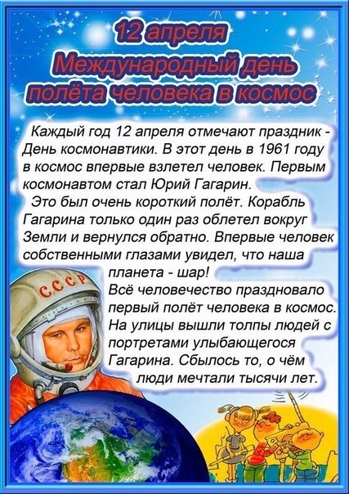](https://ok.ru/dk?cmd=PopLayerPhoto&st.layer.cmd=PopLayerPhotoOuter&st.layer.type=GROUP&st.layer.revNav=off&st.layer.limitedUi=false&st.layer.closeLayers=off&st.layer.sphotoIds=889162496767%3B889162497023%3B889162497279%3B889162497535%3B889162497791&st.layer.showNav=on&st.layer.photoAlbumId=55466577756415&st.layer.epm=off&st.layer.photoId=889162497023&st.layer.wasRedirect%2C=off&st.layer.opl=off&st.layer.navStartPhotoId=889162497023&st.layer.navStartAlbumId%2C=55466577756415&st.layer.sbd=off&st.cmd=altGroupForum&st.groupId=55466573562111&st._aid=GroupTopicLayer_openPhotoLayer)

[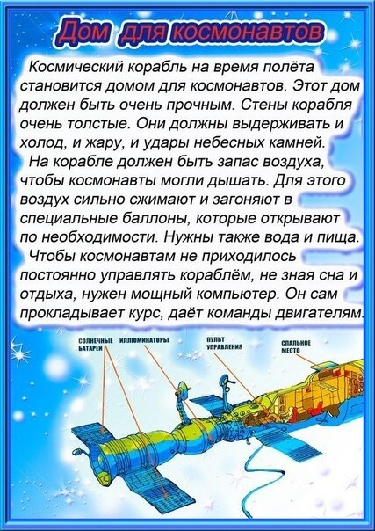](https://ok.ru/dk?cmd=PopLayerPhoto&st.layer.cmd=PopLayerPhotoOuter&st.layer.type=GROUP&st.layer.revNav=off&st.layer.limitedUi=false&st.layer.closeLayers=off&st.layer.sphotoIds=889162496767%3B889162497023%3B889162497279%3B889162497535%3B889162497791&st.layer.showNav=on&st.layer.photoAlbumId=55466577756415&st.layer.epm=off&st.layer.photoId=889162497535&st.layer.wasRedirect%2C=off&st.layer.opl=off&st.layer.navStartPhotoId=889162497535&st.layer.navStartAlbumId%2C=55466577756415&st.layer.sbd=off&st.cmd=altGroupForum&st.groupId=55466573562111&st._aid=GroupTopicLayer_openPhotoLayer)

[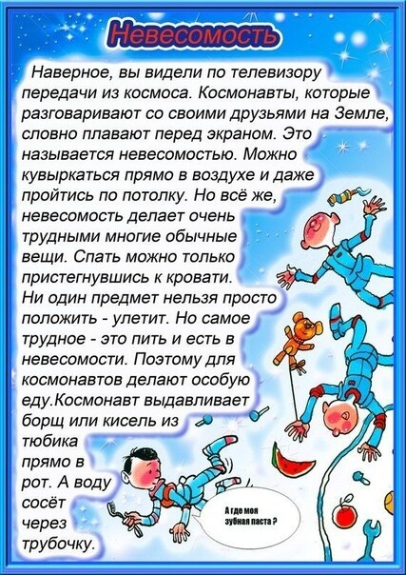](https://ok.ru/dk?cmd=PopLayerPhoto&st.layer.cmd=PopLayerPhotoOuter&st.layer.type=GROUP&st.layer.revNav=off&st.layer.limitedUi=false&st.layer.closeLayers=off&st.layer.sphotoIds=889162496767%3B889162497023%3B889162497279%3B889162497535%3B889162497791&st.layer.showNav=on&st.layer.photoAlbumId=55466577756415&st.layer.epm=off&st.layer.photoId=889162497279&st.layer.wasRedirect%2C=off&st.layer.opl=off&st.layer.navStartPhotoId=889162497279&st.layer.navStartAlbumId%2C=55466577756415&st.layer.sbd=off&st.cmd=altGroupForum&st.groupId=55466573562111&st._aid=GroupTopicLayer_openPhotoLayer)

[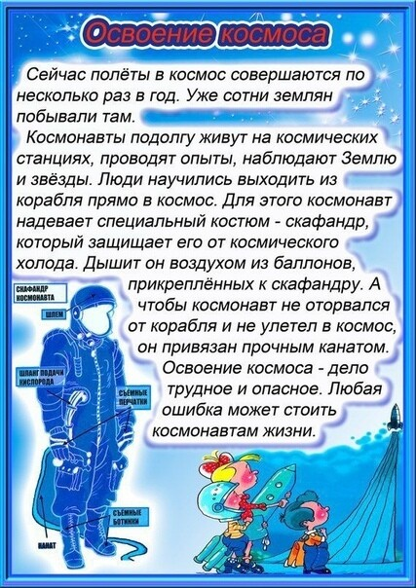](https://ok.ru/dk?cmd=PopLayerPhoto&st.layer.cmd=PopLayerPhotoOuter&st.layer.type=GROUP&st.layer.revNav=off&st.layer.limitedUi=false&st.layer.closeLayers=off&st.layer.sphotoIds=889162496767%3B889162497023%3B889162497279%3B889162497535%3B889162497791&st.layer.showNav=on&st.layer.photoAlbumId=55466577756415&st.layer.epm=off&st.layer.photoId=889162497791&st.layer.wasRedirect%2C=off&st.layer.opl=off&st.layer.navStartPhotoId=889162497791&st.layer.navStartAlbumId%2C=55466577756415&st.layer.sbd=off&st.cmd=altGroupForum&st.groupId=55466573562111&st._aid=GroupTopicLayer_openPhotoLayer)