[](https://ok.ru/dk?cmd=PopLayerPhoto&st.layer.cmd=PopLayerPhotoOuter&st.layer.type=GROUP&st.layer.revNav=off&st.layer.limitedUi=false&st.layer.closeLayers=off&st.layer.sphotoIds=889054726911%3B889054727167%3B889054727423%3B889054727679%3B889054727935%3B889054728191%3B889054728447%3B889054728703&st.layer.showNav=on&st.layer.photoAlbumId=55466577756415&st.layer.epm=off&st.layer.photoId=889054726911&st.layer.wasRedirect%2C=off&st.layer.opl=off&st.layer.navStartPhotoId=889054726911&st.layer.navStartAlbumId%2C=55466577756415&st.layer.sbd=off&st.cmd=altGroupForum&st.groupId=55466573562111&st._aid=GroupTopicLayer_openPhotoLayer)

[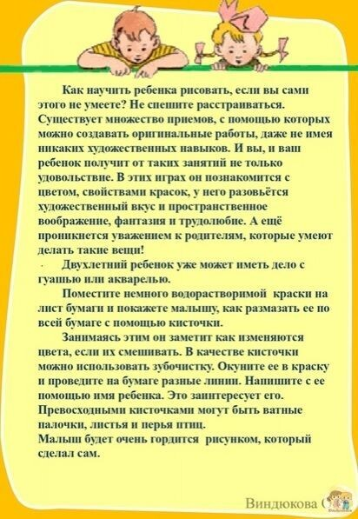](https://ok.ru/dk?cmd=PopLayerPhoto&st.layer.cmd=PopLayerPhotoOuter&st.layer.type=GROUP&st.layer.revNav=off&st.layer.limitedUi=false&st.layer.closeLayers=off&st.layer.sphotoIds=889054726911%3B889054727167%3B889054727423%3B889054727679%3B889054727935%3B889054728191%3B889054728447%3B889054728703&st.layer.showNav=on&st.layer.photoAlbumId=55466577756415&st.layer.epm=off&st.layer.photoId=889054727167&st.layer.wasRedirect%2C=off&st.layer.opl=off&st.layer.navStartPhotoId=889054727167&st.layer.navStartAlbumId%2C=55466577756415&st.layer.sbd=off&st.cmd=altGroupForum&st.groupId=55466573562111&st._aid=GroupTopicLayer_openPhotoLayer)

[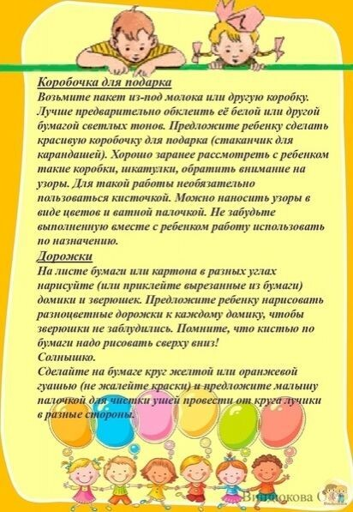](https://ok.ru/dk?cmd=PopLayerPhoto&st.layer.cmd=PopLayerPhotoOuter&st.layer.type=GROUP&st.layer.revNav=off&st.layer.limitedUi=false&st.layer.closeLayers=off&st.layer.sphotoIds=889054726911%3B889054727167%3B889054727423%3B889054727679%3B889054727935%3B889054728191%3B889054728447%3B889054728703&st.layer.showNav=on&st.layer.photoAlbumId=55466577756415&st.layer.epm=off&st.layer.photoId=889054728191&st.layer.wasRedirect%2C=off&st.layer.opl=off&st.layer.navStartPhotoId=889054728191&st.layer.navStartAlbumId%2C=55466577756415&st.layer.sbd=off&st.cmd=altGroupForum&st.groupId=55466573562111&st._aid=GroupTopicLayer_openPhotoLayer)

[](https://ok.ru/dk?cmd=PopLayerPhoto&st.layer.cmd=PopLayerPhotoOuter&st.layer.type=GROUP&st.layer.revNav=off&st.layer.limitedUi=false&st.layer.closeLayers=off&st.layer.sphotoIds=889054726911%3B889054727167%3B889054727423%3B889054727679%3B889054727935%3B889054728191%3B889054728447%3B889054728703&st.layer.showNav=on&st.layer.photoAlbumId=55466577756415&st.layer.epm=off&st.layer.photoId=889054727423&st.layer.wasRedirect%2C=off&st.layer.opl=off&st.layer.navStartPhotoId=889054727423&st.layer.navStartAlbumId%2C=55466577756415&st.layer.sbd=off&st.cmd=altGroupForum&st.groupId=55466573562111&st._aid=GroupTopicLayer_openPhotoLayer)

[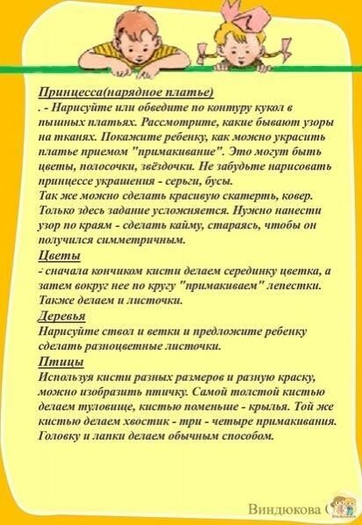](https://ok.ru/dk?cmd=PopLayerPhoto&st.layer.cmd=PopLayerPhotoOuter&st.layer.type=GROUP&st.layer.revNav=off&st.layer.limitedUi=false&st.layer.closeLayers=off&st.layer.sphotoIds=889054726911%3B889054727167%3B889054727423%3B889054727679%3B889054727935%3B889054728191%3B889054728447%3B889054728703&st.layer.showNav=on&st.layer.photoAlbumId=55466577756415&st.layer.epm=off&st.layer.photoId=889054727679&st.layer.wasRedirect%2C=off&st.layer.opl=off&st.layer.navStartPhotoId=889054727679&st.layer.navStartAlbumId%2C=55466577756415&st.layer.sbd=off&st.cmd=altGroupForum&st.groupId=55466573562111&st._aid=GroupTopicLayer_openPhotoLayer)

[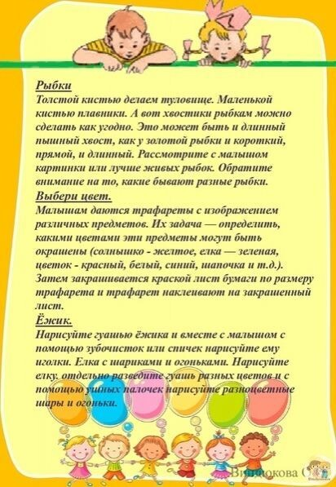](https://ok.ru/dk?cmd=PopLayerPhoto&st.layer.cmd=PopLayerPhotoOuter&st.layer.type=GROUP&st.layer.revNav=off&st.layer.limitedUi=false&st.layer.closeLayers=off&st.layer.sphotoIds=889054726911%3B889054727167%3B889054727423%3B889054727679%3B889054727935%3B889054728191%3B889054728447%3B889054728703&st.layer.showNav=on&st.layer.photoAlbumId=55466577756415&st.layer.epm=off&st.layer.photoId=889054727935&st.layer.wasRedirect%2C=off&st.layer.opl=off&st.layer.navStartPhotoId=889054727935&st.layer.navStartAlbumId%2C=55466577756415&st.layer.sbd=off&st.cmd=altGroupForum&st.groupId=55466573562111&st._aid=GroupTopicLayer_openPhotoLayer)

[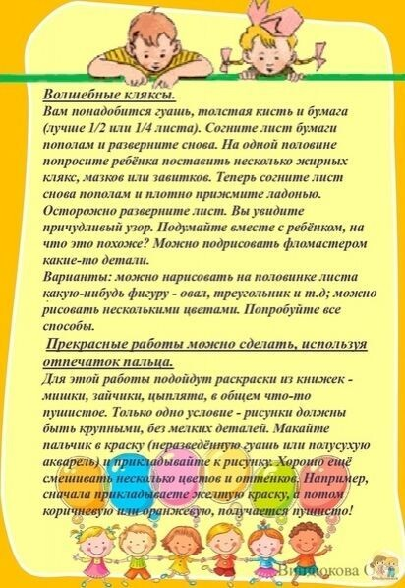](https://ok.ru/dk?cmd=PopLayerPhoto&st.layer.cmd=PopLayerPhotoOuter&st.layer.type=GROUP&st.layer.revNav=off&st.layer.limitedUi=false&st.layer.closeLayers=off&st.layer.sphotoIds=889054726911%3B889054727167%3B889054727423%3B889054727679%3B889054727935%3B889054728191%3B889054728447%3B889054728703&st.layer.showNav=on&st.layer.photoAlbumId=55466577756415&st.layer.epm=off&st.layer.photoId=889054728447&st.layer.wasRedirect%2C=off&st.layer.opl=off&st.layer.navStartPhotoId=889054728447&st.layer.navStartAlbumId%2C=55466577756415&st.layer.sbd=off&st.cmd=altGroupForum&st.groupId=55466573562111&st._aid=GroupTopicLayer_openPhotoLayer)

[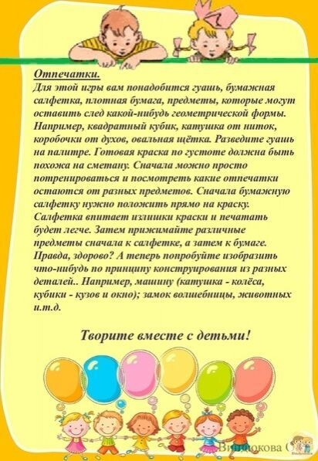](https://ok.ru/dk?cmd=PopLayerPhoto&st.layer.cmd=PopLayerPhotoOuter&st.layer.type=GROUP&st.layer.revNav=off&st.layer.limitedUi=false&st.layer.closeLayers=off&st.layer.sphotoIds=889054726911%3B889054727167%3B889054727423%3B889054727679%3B889054727935%3B889054728191%3B889054728447%3B889054728703&st.layer.showNav=on&st.layer.photoAlbumId=55466577756415&st.layer.epm=off&st.layer.photoId=889054728703&st.layer.wasRedirect%2C=off&st.layer.opl=off&st.layer.navStartPhotoId=889054728703&st.layer.navStartAlbumId%2C=55466577756415&st.layer.sbd=off&st.cmd=altGroupForum&st.groupId=55466573562111&st._aid=GroupTopicLayer_openPhotoLayer)